
Five Ways Primary School

Langholm Drive Headteacher: Mrs Rachel Mander B.Ed. Hons
Heath Hayes Telephone: 01543 278071
Cannock Website: www.fiveways.staffs.sch.uk
Staffs Email: admin@fiveways.staffs.sch.uk
WS12 2EZ

Monday 4th January 2021

Year 6 Class 6SD

Dear Broomsticks,

First of all, I would like to wish you a Happy New Year and hope you had a wonderful Christmas.

Your home learning resources for this week are available on the school home learning page as well as on our Google Classroom page. I would encourage you to use the Google Classroom page as I will be updating that regularly over the next couple of days with tasks and messages for you to read. But if you don’t have access to Google Classroom then all the resources you will need are available here.
As before, there will be a scheduled Zoom meeting at 9am which will be used as a quick catch up and for me to instruct you on the structure for your learning whilst you are at home.

For Zoom sessions this week, I have put the meeting timetable below so that you know when the sessions are. The times of the Zoom sessions are in bold. The link, meeting ID and password is the same for all Zoom meetings. Please enter the Zoom meeting with your name so I know you are from our class. Remember, if you have a headset or pair of headphones that has a microphone, please plug these into your computer. You will also be able to hear me more clearly. Please try to be in a quiet room as your microphone picks up any background noise.

Zoom details
Zoom link (Please click on the link.)
Meeting ID: 944 5648 5765
Password: 5W4ys6SD

For your home learning, I would like you to aim to complete a maths and English activity following our Zoom session. In the afternoons, look at the table below and complete the afternoon activities.

Remember, you are all amazing!
See you on Zoom,

Mr Doughty 😊

Monday 4th January 2021

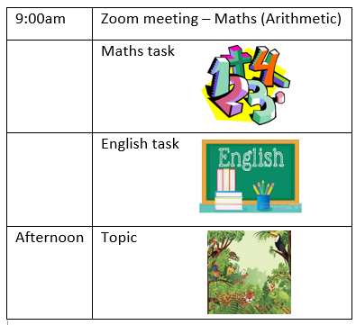

9:00am Zoom
Maths (arithmetic) – a Zoom session to do some maths work. I have designed an arithmetic worksheet for you to complete after our catch up and maths lesson on Zoom.
English (Reading Comprehension) – This reading activity will be about the next chapter from The Explorer. Read the chapter carefully and answer the questions independently.

Topic (Deforestation in the Amazon Rainforest) – There will be an informative PowerPoint about deforestation in the Amazon Rainforest on our Google classroom page. Please look through this and then complete the sorting activity I have designed for you.

Tuesday 5th January 2021

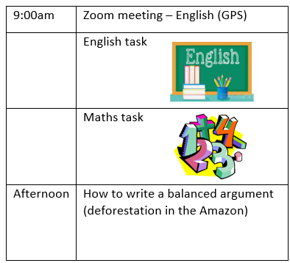

9:00am Zoom
English (GPS) – Colons. On today’s Zoom meeting we will be looking at how to identify and use colons in sentences. There will be tasks for you to complete during Zoom and then an activity for you to do afterwards.

Maths Adding & Subtracting Fractions – Recap of adding and subtracting fractions with different denominators.

How to write a balanced argument – Watch the BBC Bitesize video on what a balanced argument is.
Then, there will be a task for you to complete based on yesterday’s learning around deforestation in the Amazon.

Homework


Maths:
Read page 18 in your Maroon SATs revision book on adding fractions.
Complete page 36 in your Arithmetic SATs Homework book on Adding fractions with different denominators. As a challenge if you feel comfortable with this, have a go at page 37 as well).

English:
Read page 44 in your puprle SATs revision book on colons.
Complete the colons homework task available on Google Classroom and the school home learning page.
Choose your favourite book and use the template to write your very own book review.

Spellings
This week’s spellings are from the Year 5/6 spelling list:
Appreciate
Desperate
Interrupt
Frequently
Necessary
Suggest

Useful Resources:
Spelling Frame – Look at any of the Year 3/4 spelling rules. Practise them and play the games.
MyMaths – If you want to do some extra work, please use MyMaths as revision of tasks that we have already looked at in lessons.
Times Table Rockstars – Can you beat me?!
Draw with Rob – Pick a tutorial to have a go at.

