
Five Ways Primary School

Langholm Drive Headteacher: Mrs Rachel Mander B.Ed. Hons
Heath Hayes Telephone: 01543 278071
Cannock Website: www.fiveways.staffs.sch.uk
Staffs Email: admin@fiveways.staffs.sch.uk
WS12 2EZ
Year 5 Class 5HL

Hello Andes Class,

Again this week, it has been lovely to see so many of you working hard on your home-learning. I have loved receiving pictures of your wonderful projects via our school email address. I hope you and your families are all still having some fun at home (even with the bad weather!) and keeping safe. Have you all had a good week?

I returned back to school properly this week with Mr Doughty and our Year 6 ‘bubble’ group. It has been so lovely to see some children returning to school and hearing about what they have been up to during lockdown. We have really had a fun-filled week! On Monday afternoon, we split our group into two teams and had a small game of rounders. Believe it or not – me and my team won (even though I did not score a single rounder for my team!). However, when we played on Tuesday, Mr Doughty’s team did manage to beat us. We have also played basketball and badminton in the hall as well as taking part in penalty shoot-outs on the playground. On Saturday, it was my mom’s birthday, so we had a family (socially distanced of course!) BBQ in the back garden and played some board games. My mom especially loved her birthday cake – a big pink and purple unicorn complete with some mini unicorn cupcakes! Even Chester brought my mom some presents. He brought her a ‘Where’s Chester?’ search and find book and a pair of socks with his face on. As always, mine and Chester’s long treks have continued this week – we even saw Seth from our class twice!

For anyone who has celebrated a birthday, or will have one over the next few weeks, please let me know via our Year Five email address and you will get a special mention in our weekly class letter! I would also love to see or hear about how you have celebrated it this year.

For this week’s home learning, I would like you to aim to complete one bullet point from each section, per day. Please aim to spend between 1 to 3 hours, per day, on your home learning. Please use the resources on the website to help you navigate this week’s learning. Please remember, the activities listed below are just suggestions and are not compulsory, I am aware that some of you are engaging with alternative learning resources such as BBC Bitesize and The Maths Factor, if you are happier to continue with your own learning routine then please do so.

In addition to this, try to exercise for at least 1 hour per day. Remember, you can log on to The Body Coach TV to complete a PE workout with Joe Wicks. Please see the direct link to this on our website.

If you would like your work to be celebrated on our school website then send a photograph of it to: yr5photographs@fiveways.staffs.sch.uk - please remember to check with your parent first. I have really enjoyed seeing the photographs of you working from home on our school website.

You are all continuing to make me so proud,
Keep keeping safe,
Miss Lane 😊

Week commencing Monday 1st June 2020
Weekly Spelling (pick one per day)
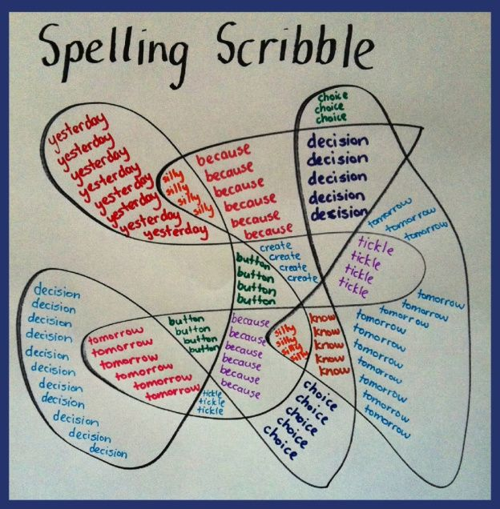
- Make a ‘spelling scribble’ of your spelling words. See example.
- Make a poster to help you learn the spellings: rhyme, restaurant, relevant, recommend, recognise, queue, pronunciation.
- Write each spelling into a sentence.
Challenge: Can you write a short story using all of the spellings for this week?
- Have a go at using some of the strategies to practise your spellings from the spelling menu.
- Practise using the free spelling tile games on Spelling Frame here.
Weekly Reading (pick one per day)
- Bug Club – read a book from your allocated books and complete the quiz questions within the book.
- National Oak Academy Lesson 1: Reading Comprehension
- National Oak Academy Lesson 2: Reading Comprehension
- Reading comprehension task: ‘The Circulatory System’ (*the link for this is provided underneath the links for this week’s letters)
- Pobble 365: ‘The Lighthouse’
Read the story starter on slide 1 and answer the following questions on slide 2.
Weekly Writing (pick one per day)
- National Oak Academy Lesson 3: Identifying the features of a balanced argument.
- National Oak Academy Lesson 4: SPaG Focus – Adverbs of Possibility.
- National Oak Academy Lesson 5: Writing a balanced argument.
- Pobble 365: ‘The Lighthouse’
Complete the tasks on slide 3 titled ‘Sentence Challenge!’ and slide 4 titled, ‘Sick sentences!’
- The theme for this week’s home learning is ‘The Circulatory System.’ We would like you to have a go at writing an explanation text about how this system works. You can use the reading comprehension text we have set as an example. For extra support, tips and tricks to write your explanation, watch the following video: https://www.bbc.co.uk/teach/class-clips-video/english-ks1-ks2-how-to-write-an-explanation/zh2kjhv
Weekly Mathematics (pick one per day)
- National Oak Academy Maths lessons Week 8 Mon-Fri: Calculating with whole numbers and decimals.
- Bitesize week 7 Maths Challenges
- MyMaths Activities that have been set by your teacher for this week.
- TTRockstars – Year 5 battle against Year 3 – who will win? Have you improved your rock speed?

*If you have been using other online maths resources like BBC Bitesize or The Maths Factor as an alternative to the Oak National Academy lessons and would prefer to continue with these, in addition to completing MyMaths challenges, then please continue to do so.
- Weekly Projects:
- Science – The circulatory system
- Bitesize Daily lesson on Wednesday 17th June. (can only be accessed on or after that date) on the Circulatory System.
- Watch Tigtag video explanation of the Heart here.
- Plan and carry out an investigation into the effects of exercise on your heart rate.
- Make predictions about heart rate during exercise, directly after an activity and at intervals of time after the activity has concluded. We already know that our heart rate increases during exercise. Therefore, explore questions to investigate, such as whether heart rate depends on activity type, or whether factors such as fitness level, body size (height or weight) or age affect heart rates before, during or after exercise. Use the planning sheet that can be found on the Home Learning page.
- Create a model of the human heart and label the key parts of the heart: Left atrium, right atrium, right ventricle, left ventricle, aorta and pulmonary artery.
- Other learning opportunities:
- 7 well being activities - Link can be found on Home Learning page of the school website. The first three are activities to do once, the four on the next page are activities you can do every day. All of these activities are based on research to help you look after your mental health and well-being.

