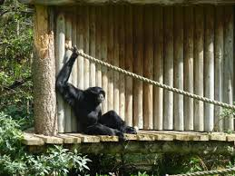
Weekly Writing Task
Balanced argument

Your task this week is to write a balanced argument about whether animals should be kept in a zoo. Remember a balanced argument is a formal piece of writing so try not to use contractions e.g, don’t, won’t, can’t, wouldn’t. Try not to write about what your opinion is. Instead, have a discussion about your opinion of the argument with a grown-up.
1) Carry out some research to get some ideas of both sides of the argument. You may use the internet and other documents that have been uploaded to the home learning page.
Here are some links that you might find useful:
https://www.bbc.co.uk/teach/what-are-zoos-for/z649f4j
https://www.stmarys-byfleet.surrey.sch.uk/attachments/download.asp?file=621&type=pdf
2) Use the following planning table to plan your balanced argument. Remember, you need to state a point, use a range of causal conjunctions and then fully explain your point by backing it up with research and statistics.
Cause and effect conjunctions
The causal conjunctions are used to explain a point.
The contrasting conjunctions are used to start a new paragraph on the opposing side of the argument.
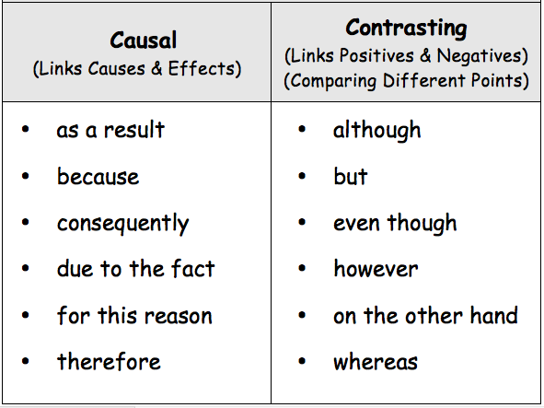

For keeping animals in a zoo
Point | Cause and effect conjunction | Explanation (use research, facts and statistics)

Point | Cause and effect conjunction | Explanation (use research, facts and statistics)
Against keeping animals in a zoo

3) Now you need to think about planning an introduction and a conclusion.
For the introduction, you need to give a definition of what a zoo is, where they are located, give a brief overview of what they aim to do and state how some people are for the idea of keeping animals in a zoo and how some people are against keeping animals in a zoo.
For the conclusion, you will need to state that there are two sides of the argument and then summarise your main points that you have written about. Try not to include any new information – a conclusion just repeats the main points that you have already included.

4) Now give your piece of writing a title. A balanced argument title always starts with should or would. Some of your titles may be a question, don’t forget your question mark!
5) Now for writing.
P1 – introduction
P2 – use 2 points from your FOR table and fully explain them.
P3 – use 2 points from your AGAINST table and fully explain them. (Start your paragraph with a contrasting conjunction.)
P4 – use 2 points from your FOR table and fully explain them. (Start your paragraph with a contrasting conjunction.)
P5 – use 2 points from your AGAINST table and fully explain them. (Start your paragraph with a contrasting conjunction.)
P6 – conclusion
You may wish to have more paragraphs as you may have more points to explain and expand. Remember, the argument has to be balanced so you will need the same number of points for keeping animals in a zoo as against keeping animals in a zoo.

Success Criteria
Try to include the following in your balanced argument:
Success criteria
Capital letters and full stops
Parenthesis () ,, --
Colon (to introduce a list and to replace the word because) :
Semi colon ; (replaces a FANBOYS)
Paragraphs
Causal conjunctions
Contrasting conjunctions

Challenge
Can you include any technical vocabulary? Try and include the following:
- Endangered
- Extinct/extinction
- Captivity
- Enclosure
- Zoochosis
- Breeding program
- Natural habitat
- Species
If you are unsure of the meaning of any of the words, make sure you find out by carrying out some research.

6) Check your balanced argument through thoroughly making sure your spelling and punctuation is correct. Remember to use a dictionary to help you!

7) Share your balanced argument with the people in your home. What do they think? What is their opinion on whether animals should be kept in a zoo?

8) Can you think of any other topics that you could write a balanced argument about?

Example Balanced Argument
Remember yours could be even better! Can you spot a contraction that should not be there?! Can you rewrite this sentence without it containing a contraction?

(Please scroll down)

