Measuring and drawing challenge

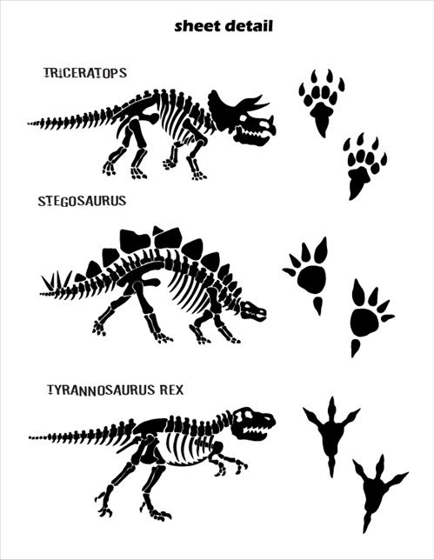 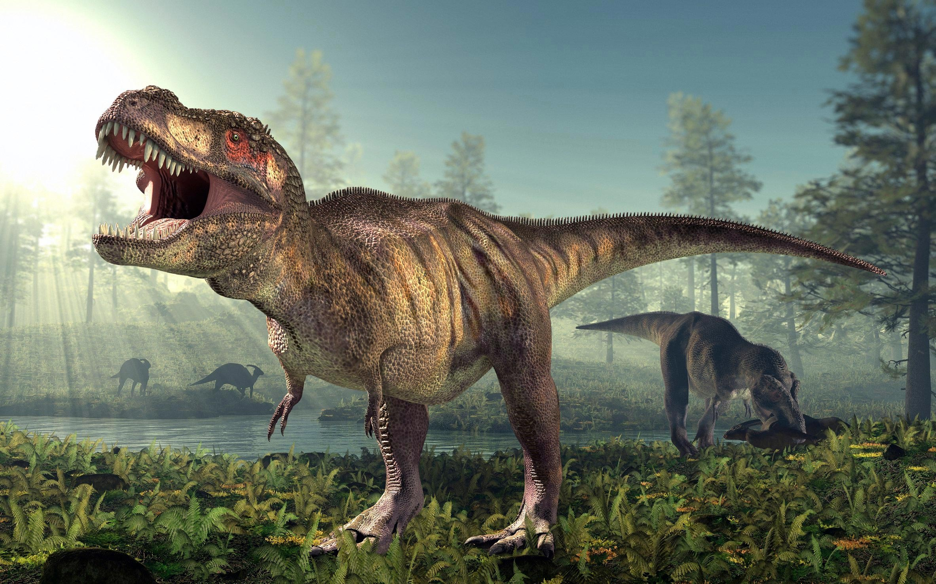

Tyrannosaurus Rex footprint

1m long and 46cm wide

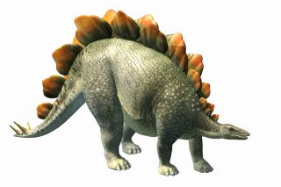

Stegosaurus footprint

35cm long and 20cm wide

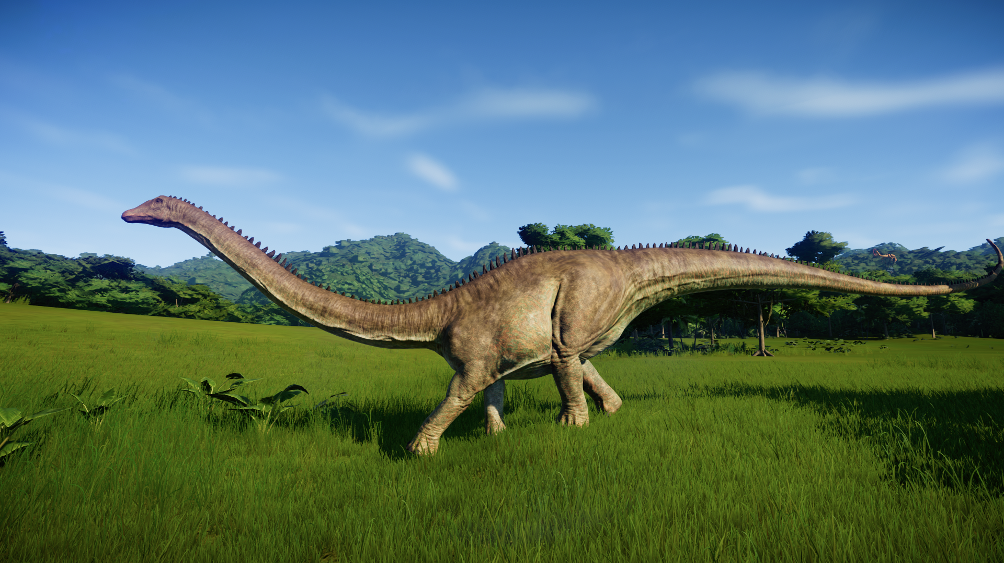

Diplodocus footprint

71cm long and 65cm wide

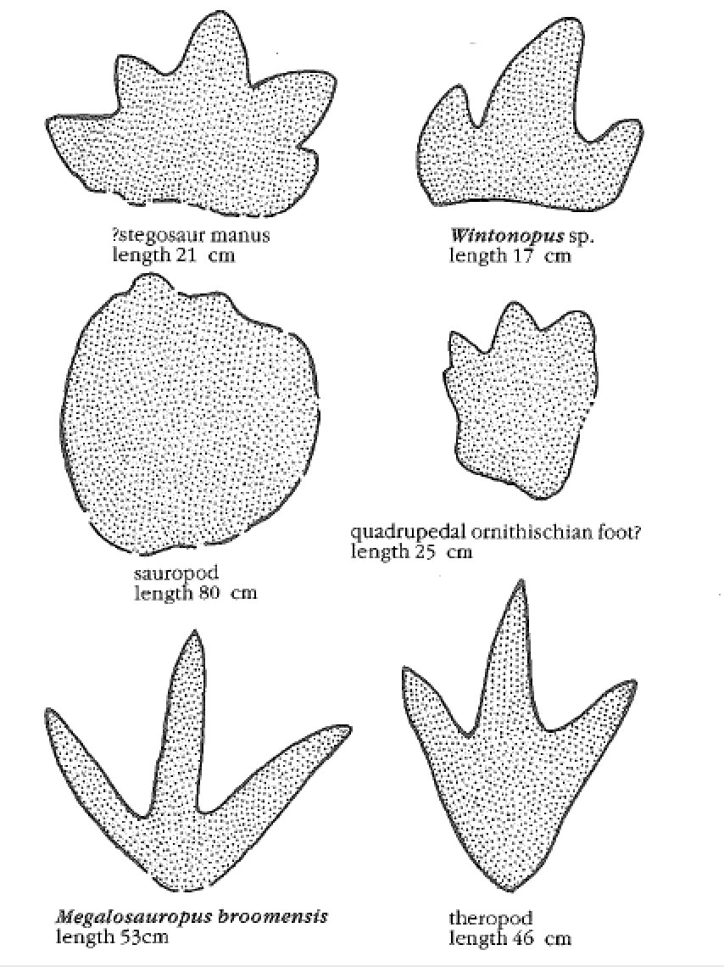 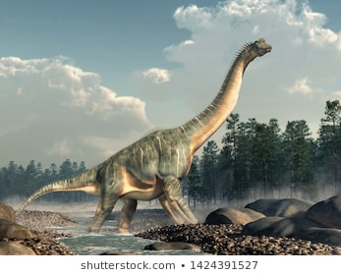

Sauropod

1m and 70cm long

1m and 50 cm wide