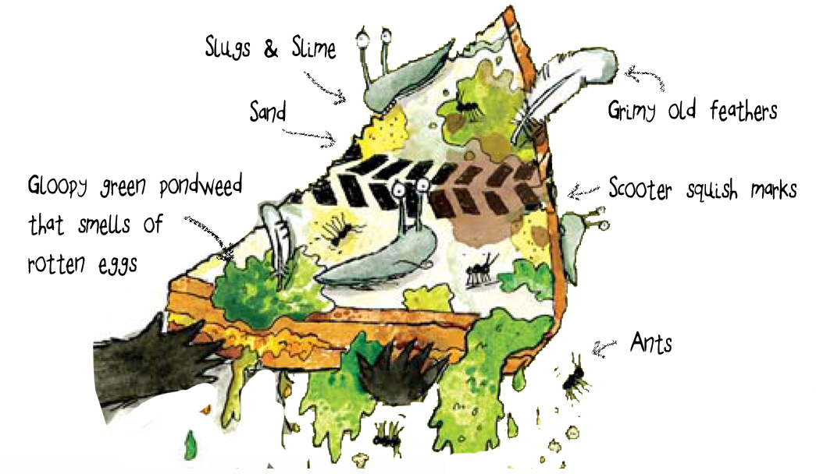 | Date __________________________________  Name _________________________________  The Disgusting Sandwich
Learning Objective: To describe the disgusting sandwich and use adjectives.
Purpose: Make the sandwich sound really disugusting by choosing interesting vocabulary.

____________________________________________________________________________________________________________________________________________________________________________________________
____________________________________________________________________________________________________________________________________________________________________________________________
____________________________________________________________________________________________________________________________________________________________________________________________
____________________________________________________________________________________________________________________________________________________________________________________________

Success criteria for writers who need support  These children should aim to write 3-5 sentences. | My evaluation
My writing makes sense and I can read it.
Punctuation
C
Handwriting
All my letters sit on the line and I have used finger spaces.

Success criteria for writers aiming to be ‘secure’ | My evaluation
Punctuation
C
3 different conjunctions
and but or because that when if
Handwriting
All of my ascenders and descenders are formed correctly.

Success criteria for writers who are ready for extra challenges | My evaluation
Punctuation
C in lists
4 different conjunctions
and but or because that when if
Handwriting Some cursive letters.

