LO: To visualise the doubling relationship between 2, 4 and 8 times tables
Task: Colour in each number from the 2s, 4s and 8 times tables.
Can you see how doubling helps to work out one from another?
Challenge: could you use this to work out the first few multiples in the 16 times tables?
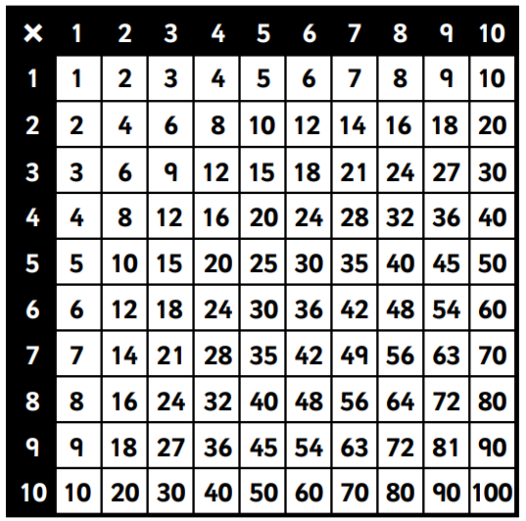
Double 2 is 4, double 4 is 8
Double 4 is 8, double 8 is 16

