
Five Ways Primary School

Langholm Drive Headteacher: Mrs Rachel Mander B.Ed. Hons
Heath Hayes Telephone: 01543 278071
Cannock Website: www.fiveways.staffs.sch.uk
Staffs Email: admin@fiveways.staffs.sch.uk
WS12 2EZ
Year 4 - Class 4HD

Hello Falcons,

I hope you are all keeping well and that you have had a super week. I have loved watching the storms this week. The storm on Tuesday evening was extremely dramatic. I find the suspense and the atmosphere of thunder and lightning quite exciting. I know that some of you may have been a little bit scared too. Do you know what causes lightning? There is a super video on Tigtag that explains what happens; login, search storms and you will see there is a short video called ‘Lightning’ and it may help you to understand them a little better.
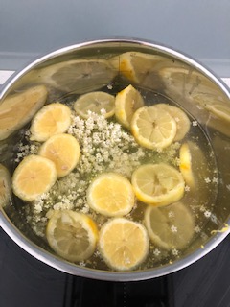

This week, I have continued to work from home. I have been busy setting home learning tasks and monitoring what you have all been doing from home. I have also enjoyed walks around the local countryside and even collected some elderflowers on my travels. Mrs Gosling gave me a recipe for elderflower cordial so I have made my very fist batch. I’m very excited to try it and hope that it tastes delicious.

It's usually around this time of year, that we start to prepare for Sports Day. This year, we need to think outside of the box and challenge ourselves to be Sporty at home. Maybe you could design a sports day for the family in the garden and get family members to join in too. You could have a series of races or even devise an obstacle course with different activity stations. We would love to see you participating. Don’t forget, you can send us photographs to the email address further down this letter.

Have you started to prepare an entry for the Caroline Bowers Art Prize? If you have completed yours, we would love to see a photograph! You can email it to the email address below. The 'actual' pieces are still to remain at home until we notify you otherwise.

For this week’s home learning, I would like you to aim to complete one bullet point from each section, per day. Please aim to spend between 1 to 3 hours, per day, on your home learning. Please use the resources on the website to help you navigate the learning for this week.

In addition to this, try to exercise for at least 1 hour per day. Remember, you can log on to The Body Coach TV to complete a PE workout with Joe Wicks. Please see the direct link to this on our website.

If you would like your work to be celebrated on our school website then ask your grown-ups to send a photograph of it to: yr4photographs@fiveways.staffs.sch.uk . I have really enjoyed seeing the photographs of you working from home, on our school website.

Enjoy your home learning.

Mrs Darby

Week Commencing: Monday 22nd June 2020

Weekly Spelling (pick one per day) | Weekly Reading (pick one per day)
- Nessy reading spelling challenge  - This week we are going to be looking at the prefixes un- and dis-. Un- means ‘not’. Dis- gives the word the opposite meaning.  Unfinished, unfair, unusual  Disinfect, disappear, dislike  - Make a poster to help you learn the spellings that you have been given using lots of different techniques, e.g. pyramid words, rainbow words, bubble writing, writing the vowels in a different colour.  - Write each spelling into a sentence:  Unfinished, unfair, unusual  Disinfect, disappear, dislike  - Look, cover, write, check each spelling or ask a grown up to ‘quiz’ you on the six spellings that you have been given this week.  - See how many other words you can find that begin with the prefixes un- and dis-. | - Reading Bug Club .  - Oak National Academy, week 9, Monday, reading comprehension.  - Oak National Academy, week 9, Tuesday,  reading comprehension.  - Oak National Academy, week 9, Wednesday, identify the key features.  - Humpty Dumpty reading comprehension (found on the website).  - Hansel and Gretel reading comprehension (found on the website).
Weekly Writing | Weekly Mathematics (pick one per day)
- Oak National Academy, week 8, Thursday, SPAG focus.  - Oak National Academy, week 8, Friday. To use key features to write your own adventure story.  - Choose any book from home. Copy the first ten lines of the text onto a piece of lined paper using your very best joined handwriting. Think carefully about the size of your letters. Make sure the tall letters stretch to the line above. Remember, we do not join from capital letters.  - Grammar mat (found on the website).  - List as many words as you can that help us to describe how we are feeling. For example: excited, deflated, disappointed, anxious. You might like to write each word in a colour that matches the feeling. I would choose to write disappointed in blue, whereas I would write excited in a bright pink. What colour would you use to write the word ‘furious’? | - Oak National Academy - Lesson 1: To describe positions on a 2D grid as coordinates. (Week 9 – Monday).  - Oak National Academy - Lesson 2: To investigate a problem describing positions on a 2D grid as coordinates. (Week 9 – Tuesday).  - Oak National Academy - Lesson 3: To plot specific points and draw sides to complete a given triangle. (Week 9 – Wednesday).  - Oak National Academy - Lesson 4: To describe movements between positions as translations of a given unit to the left/right, up/down. (Week 9 – Thursday).  - Oak National Academy - Lesson 5: To describe movements between positions as translations of a given unit to the left/right, up/down. (Week 9 – Friday).  - TTRockstars – Please complete 11 studio games to refresh your rock star status. Let’s see how many rockstars we can get in Year Four!  - MyMaths – coordinates 1, translations, mixed tables 2-12.  - Zoo coordinates (worksheet found on website).  - Emoji coordinates (worksheet found on website).  - Translations on a grid (worksheet on the website).
Weekly Project:

Food chains/webs:

Login to Tigtag using the login details at the end of this letter.
In the search bar in the top right corner, type food chains. You should see a topic web that looks like this one:

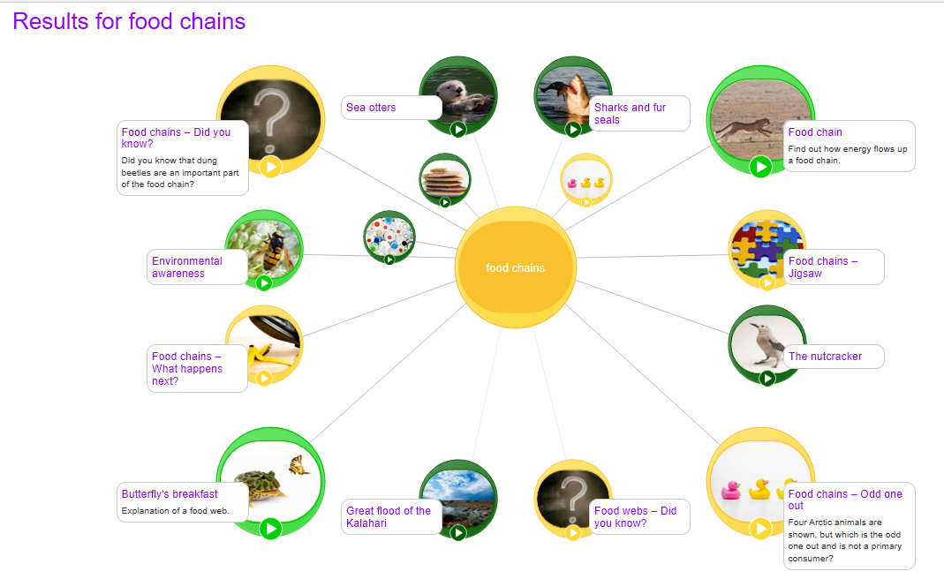

Watch the video called Butterfly’s breakfast.
Using your knowledge from the video, write a definition of a carnivore, a herbivore and an omnivore. Discuss with a grown up which category a human would fit into?

You can now watch the other videos on this topic web: Food Chains and Sharks and Fur Seals. A series of organisms that rely on each other for food form a food chain. Sometimes, food chains can link together to form a food web. I have added a couple of diagrams to the school website called ‘Marine Food Web’ and ‘Land Food Web’ that will help to demonstrate the flow of energy through the food web.

Have a go at drawing a food web for a particular animal. For example, a cat or a dolphin.

On the website, you will find a cut and stick activity called ‘Food Chain Tubes’. Cut them out and stick the tubes. Place one tube on top of the other to show the order of the food chain.

Other Useful Resources:
https://www.bbc.co.uk/bitesize

https://www.tigtagworld.co.uk/ Username: TigtagStudent
Password: schoolsout

