Fractions
The children in Year 4 have recently been looking at multiplication and division. Our next step would have been to look at fractions. As a starting point, I would like to direct you to some super Home Learning resources. As I’ve already mentioned, the activities are meant as a starting point and so I am therefore directing you a Year Three page on which we can build. However, I think the video tutorials are superb and these short video tutorials are supported by activities and marksheets to reinforce the learning.

Firstly, log in to White Rose Maths

https://whiterosemaths.com/

Click the Home Learning tab at the top.

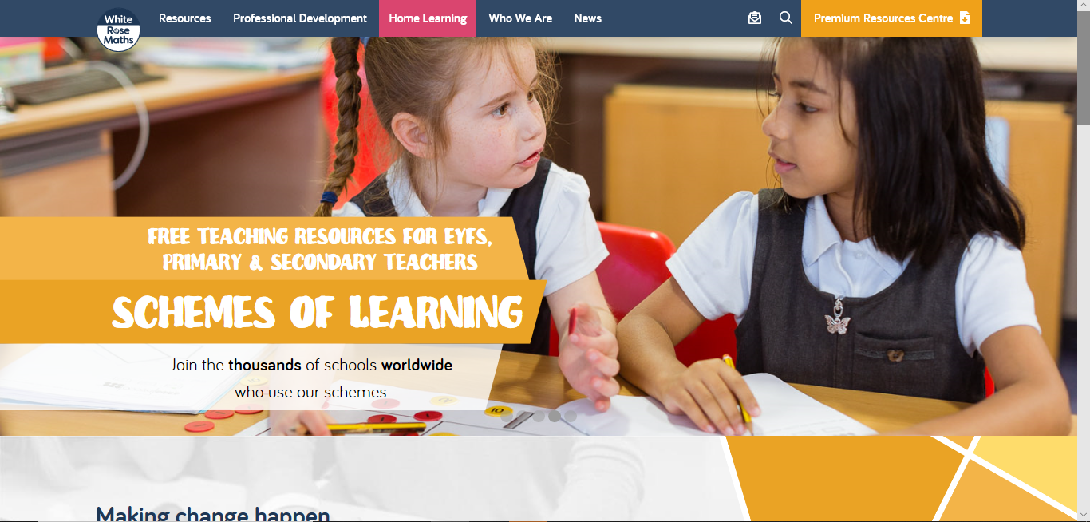

Next, select Year Three.

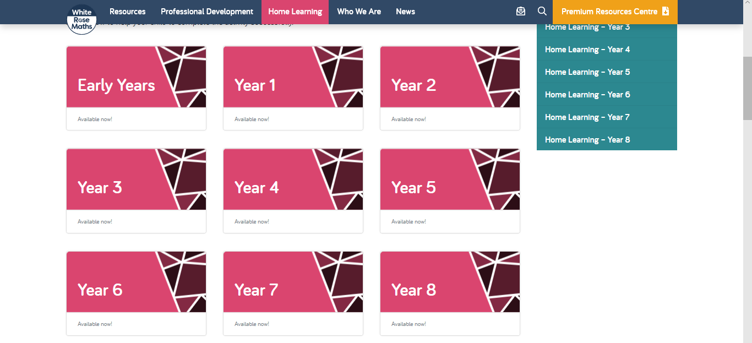

Select Week 1:

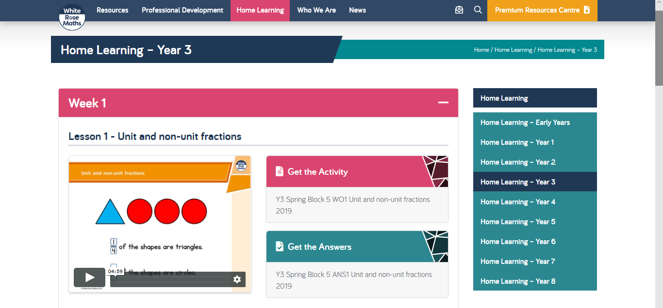

There is a series of 5 lessons to work through.
Once the children have completed these lessons, we can build upon this learning.

