wb 11/1/21 – French – Different pet names
Follow the link below and listen to the different pet names in French. There are some listening activities and games there.
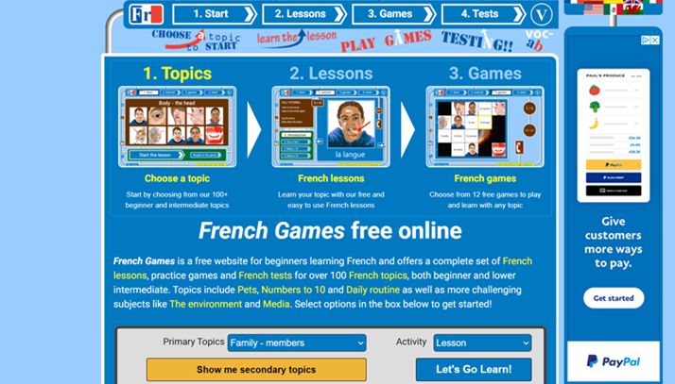
Repeat the correct vocabulary whenever you hear it - show off your amazing, authentic pronunciation!
Can you create an action that helps you remember the sound? A silly story? Like we do in class?
How many feminine nouns are there? How do you know?
How many cognates are there? Can you explain what a cognate is to someone at home?
Do you have any pets that don’t feature in this activity? Can you find out how to say them in French?

https://www.french-games.net/?fbclid=IwAR3qAQM_8yJ_WhbHr0vLr8tbxE_PzlmtPRn8ou8hSmBhg7E4kJdXqx3C5ww

