Leopards Maths Exercises – WC 8th June
Topic: Geometry
Weekly Learning Objectives:
- To compare angles
- To know acute and obtuse angles, right-angles and a straight line
- To measure and draw straight lines accurately
- To draw and identify 2D shapes accurately

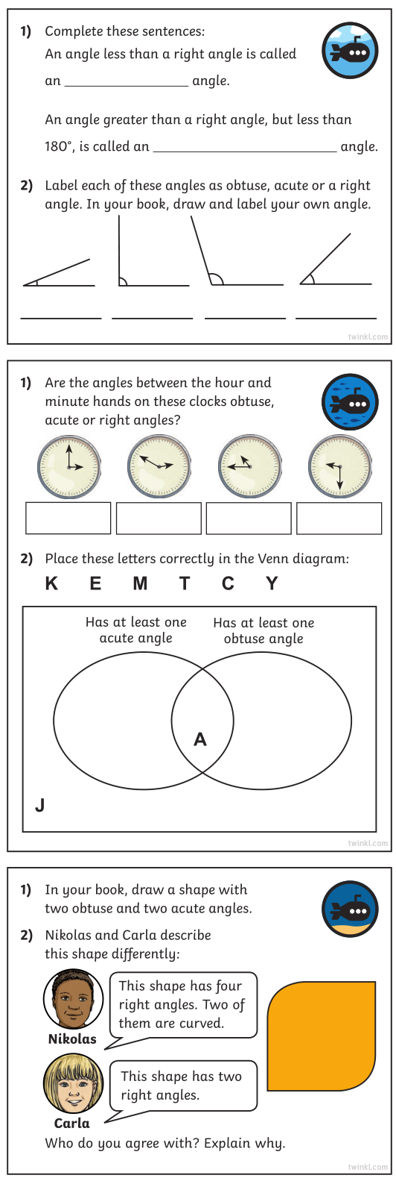
Practical activity idea. Make triangles from twigs and branches you can find whilst outdoors and point to the angle inside the shape to name it: Acute, Obtuse, Right Angle, or Straight Line.
Notes for parents: Children could also draw shapes and patterns with a ruler, measuring the straight lines accurately as well to the nearest mm such as 15.6cm and converting this measurement to mm 156mm.
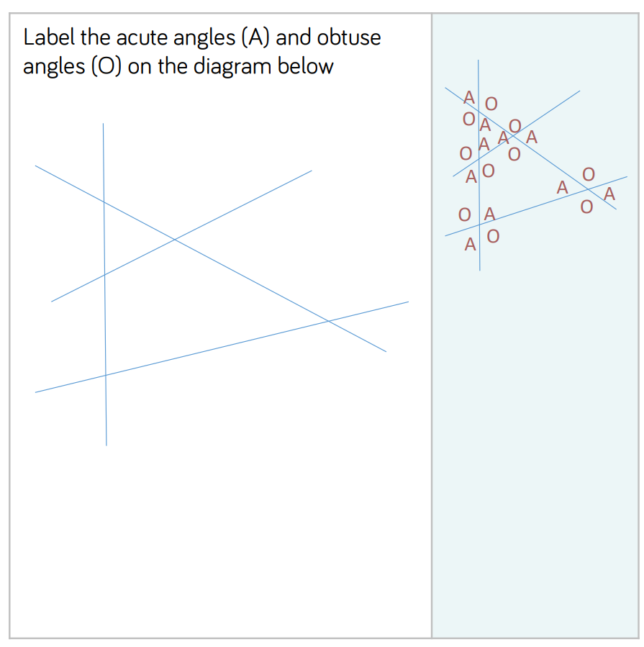
Mathematical talk and guidance for this module:
What is an angle?
What is an acute angle? (Give 3 examples of acute angles and ask them to identify what’s the same about them. Draw out that they are all smaller than a right-angle).
What’s an obtuse angle? (Repeat activity by giving 3 examples of obtuse angles).
Can you give me a time where the hands on the clock make an acute/obtuse angle?
Can you see an acute/obtuse angle around the room? (This is fun to do when its slightly dark and to use a torch to go on a hunt for them)
Can you draw me a shape that contains acute/obtuse angles?
Mr Woodward recommends: spending some time on A Maths Dictionary for Kids viewing the definitions of the terms below and looking at the interactive examples online.

A Maths Dictionary for Kids troubleshooting:
If you are viewing the website on Google Chrome and the page displayed has a jigsaw piece which says that Adobe Flash Player is blocked, in the very top-right corner of the browser screen, there are 3 vertical dots. Press these, then go down onto Settings, type ‘flash’, into the search bar at the top and change the Flash setting highlighted to ‘Always ask first’. Refresh the website, then click the jigsaw piece puzzle in the middle of the screen and it will ask you to allow Flash. Press allow and it should now work. Any problems, please email me: MrDWoodward@fiveways.staffs.sch.uk

