Leopards Maths Guidance
This document is aimed at parents to help support their child’s home learning. There are examples of fluency problems, a vocabulary check list as part of the ‘Mathematical Talk’ with some examples of Fluency problems and Reasoning problems.
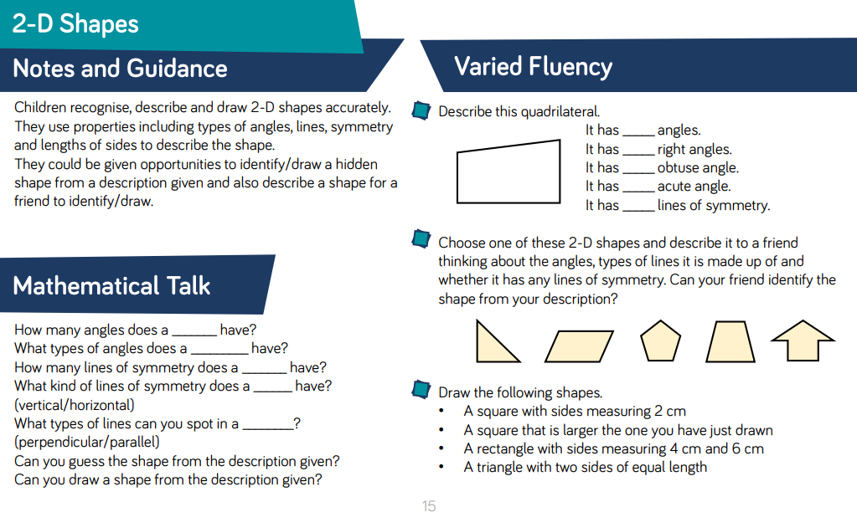
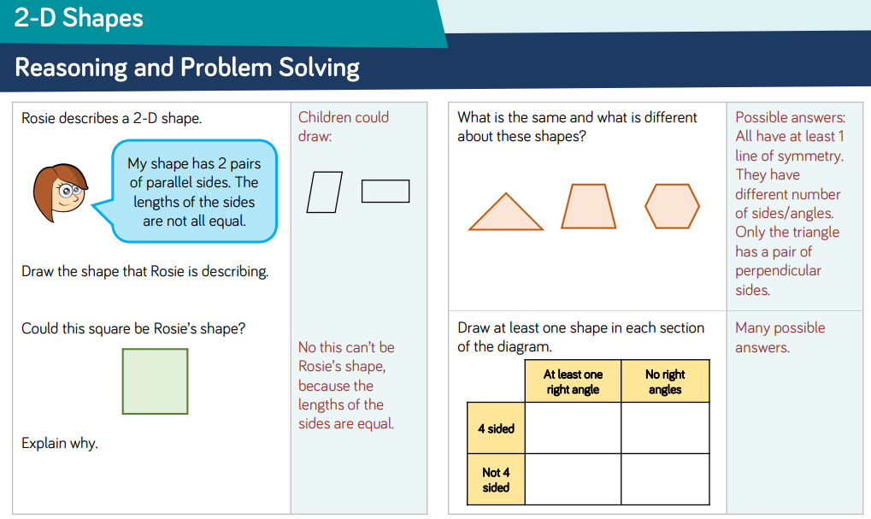
Mr Woodward recommends: 2D and 3D shape work should be as practical as possible. If you can, go outside and use sticks, twigs or whatever you can find to make these 2D shapes. Make them big, small, regular and irregular. Go on a hunt for ‘right-angles’ using a torch in the dark. Make sure ‘sides’ are used for 2D shapes and not ‘Faces’ as this is for 3D shapes.
Example game
Blindfolded, can you feel what shape you have in front of you? Can you describe the shape whilst feeling it?
https://www.educateoutside.com/resource/blindfolded-shape-game/
What natural 2D shapes can you find in nature and outdoors?

