Wb 11/1/21 – Music - David Walliams' Marvellous Musical Podcasts
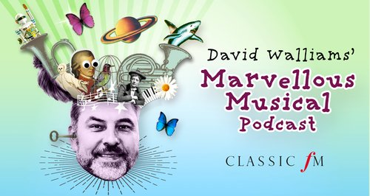
https://www.classicfm.com/music-news/david-walliams-marvellous-musical-podcast/
Listen to one of David Walliams’ Marvellous Musical Podcasts in order to find out about a famous composer.

