RE – Preparing for Special Events
We are starting our new RE topic this week about Lent.
I would like you to consider ways in which people prepare for special events. Special events are things like weddings, getting a pet, going on holiday, moving house, a baby being born etc.
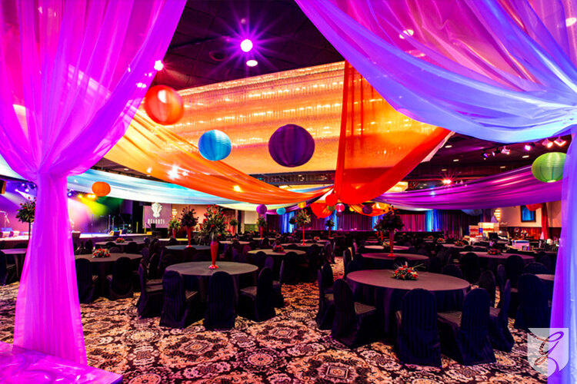

Think of a special event. List the event and then the preparation that is required.

Example
Special Event: Getting a new kitten

Preparation required:- Cat bed, kitten food, pet insurance, cat toys, kitten collar, name tag, think of a suitable name.

My Answer

Special Event:

Preparation required:-

