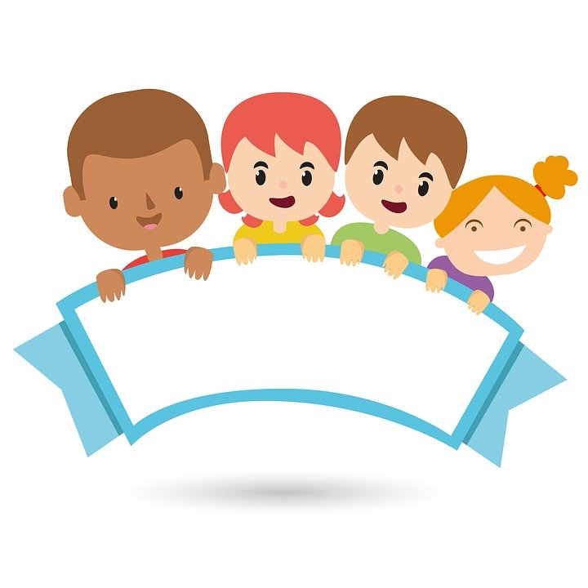
Reception Home Project!
Design and create a story book character
(please read the whole document before making the story character, as each area of learning is focussed on a different part of the project)
Areas of learning: | Early learning Goal: | Task/Activity:
Expressive Art and Design:  Exploring and using media and materials | Children sing songs, make music and dance, and experiment with ways of changing them. They safely use and explore a variety of materials, tools and techniques, experimenting with colour, design, texture, form and function. | To create a story book character using different materials and tools.  This can be made using:  - Recycled cardboard or plastics. This is called junk modelling.  - Art and crafts equipment such as paper, pens, pencils etc...  - Construction kits, such as Lego and Knex.
Personal, Social and Emotional Development:  Self-confidence and self-awareness | Children are confident to try new activities, and say why they like some activities more than others. They are confident to speak in a familiar group, will talk about their ideas, and will choose the resources they need for their chosen activities. They say when they do or don’t need help. | Show their project to the family.  Ask questions:  - Can you explain how you made it?  - What is your favourite part?  - What are you not happy with?  - How could you improve it?
Communication and Language:  Speaking | Children express themselves effectively, showing awareness of listeners’ needs. They use past, present and future forms accurately when talking about events that have happened or are to happen in the future. They develop their own narratives and explanations by connecting ideas or events. | How did they speak in their show and tell time?  Did they seem confident?  Could they answer questions?
Physical development:  Moving and Handling | Children show good control and co-ordination in large and small movements. They move confidently in a range of ways, safely negotiating space. They handle equipment and tools effectively, including pencils for writing. | Could they add more to make a moving part?  Did they need help using the equipment? Can they make one on their own without adult support?  TO support this goal also see, area of learning – writing..
Literacy:  Reading | Children read and understand simple sentences. They use phonic knowledge to decode regular words and read them aloud accurately. They also read some common irregular words. They demonstrate understanding when talking with others about what they have read. | When reading the story, see if your child can read some words or simple sentences too.  Can they spot tricky words:  Phase 2: I, the, go, no, to, into  Phase 3: he, she, we, me, be,  they, you, all, are, my, her, was  Phase 4: have, like, so, do, some, come, said, were, there, little, one, when, what, out
Literacy:  Writing | Children use their phonic knowledge to write words in ways which match their spoken sounds. They also write some irregular common words. They write simple sentences which can be read by themselves and others. Some words are spelt correctly and others are phonetically plausible. | To make a list of resources they have used or going to use, e.g.  box  paper  pen  tub  (Depending of their development you may see initial letters or phonics sounds they know, used incorrectly. This is normal and part of the development process please praise them!)  Discuss how each item needs to be on a separate line.
Mathematics:  Number | Children count reliably with numbers from one to 20, place them in order and say which number is one more or one less than a given number. Using quantities and objects, they add and subtract two single-digit numbers and count on or back to find the answer. They solve problems, including doubling, halving and sharing. | Can they count all the resources they have used?  Take one away – how many now? Did they recount?  Discuss one less and one more than their number.
Mathematics:  Shape, Space and Measure | Children use everyday language to talk about size, weight, capacity, position, distance, time and money to compare quantities and objects and to solve problems. They recognise, create and describe patterns. They explore characteristics of everyday objects and shapes and use mathematical language to describe them. | See if they can find the biggest item or the smallest item out of their equipment.  Talk about the shapes of each item. Can they describe it?
Understanding the World:  The World | Children know about similarities and differences in relation to places, objects, materials and living things. They talk about the features of their own immediate environment and how environments might vary from one another. They make observations of animals and plants and explain why some things occur, and talk about changes. | Talk about the environment their character needs. E.g. pig = farm.  Can they make or find an environment around the house/garden that their character would like? Or if not can they make one?  Can they use natural objects around the home to make the same character?  (using stones, leaves, mud, sticks etc)  Compare them – was it easier to make the natural character?
Understanding the World:  People and communities | Children talk about past and present events in their own lives and in the lives of family members. They know that other children don’t always enjoy the same things, and are sensitive to this. They know about similarities and differences between themselves and others, and among families, communities and traditions. | Can they talk about the story they have read?  Does it have a problem in it? Can they identify that problem?  How would they fix it?  Is the story something that can happen in real life or fantasy?  Has something happen to them similar to the problem in the story?
Understanding the World:  Technology | Children recognise that a range of technology is used in places such as homes and schools. They select and use technology for particular purposes. | Can they use a device at home to take a photo of their finished project?  Did they need help to use it?

As practitioners we also look at the Characteristics of Effective Learning to help your child to develop. If you are unsure about the goals or want to know more please see the Development Matters document that can be found online.

Thank you,
The Reception Team

