
Five Ways Primary School

Langholm Drive Headteacher: Mrs Rachel Mander B.Ed. Hons
Heath Hayes Telephone: 01543 278071
Cannock Website: www.fiveways.staffs.sch.uk
Staffs Email: admin@fiveways.staffs.sch.uk
WS12 2EZ
Year 5 Class 5JK

Dear Rockies,
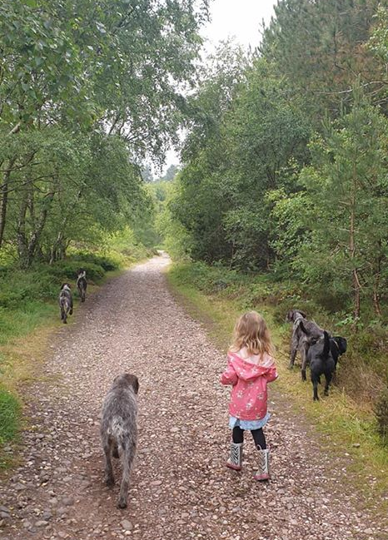
I hope you have all had a good week. Last week, I was in school with a Year 6 bubble group. It was lovely to see them back in school. I’ve also managed to get out for a few walks this week which I’ve really enjoyed. Despite moving house to nearly two years ago, it was only this week that I walked up Huntington Pit Mound to where the St George’s flag flies, the views are beautiful and I could even spot my house from up there. On Wednesday, Olivia and I joined a friend for a walk over one of the many tracks on Cannock Chase with her 5 beautiful and very well behaved dogs. Olivia loved being part of the pack and joined the dogs as they splashed through all of the muddy puddles.

What have you all been up to? I am missing you all terribly! The Year 5 email has been quite quiet lately, please get in touch and give me an update of how you all are. All I ask that if you attach any photos then please ask your adult at home to make it clear if permission is given to share them on the website. If not that’s fine I’ll make sure they are not added. The address is yr5photographs@fiveways.staffs.sch.uk - please remember to check with your parent first.

For those of you who have celebrated a birthday, or have one during this Lockdown, I would like to wish you a happy birthday! I would like to see or hear about how you celebrated it this year.

For this week’s home learning, I would like you to aim to complete one bullet point from each section, per day. Please aim to spend between 1 to 3 hours, per day, on your home learning. Please use the resources on the website to help you navigate this week’s learning. Please remember, the activities listed below are just suggestions and are not compulsory, I am aware that some of you are engaging with alternative learning resources such as BBC Bitesize and The Maths Factor, if you are happier to continue with your own learning routine then please do so.
In addition to this, try to exercise for at least 1 hour per day. Remember, you can log on to The Body Coach TV to complete a PE workout with Joe Wicks. Please see the direct link to this on our website.
Enjoy your home learning. Keep making me super proud.
Missing you all,

Miss Kershaw 😊

Week commencing Monday 15th June 2020
Weekly Spelling (pick one per day)
- Nessy reading spelling challenge
- This weeks spelling words – focus ending -ence/-ance /ency: decency, frequency, confidence, assistance, hesitancy
- Practise using the free spelling tile games on Spelling Frame here.
- Write each spelling using pyramid writing: decency, frequency, confidence, assistance, hesitancy
- Write each spelling word in a sentence.
- Look, cover, write, check each spelling or ask a grown up to ‘quiz’ you on this weeks spellings.
Weekly Reading (pick one per day)
- Bug Club – read a book from your allocated books and complete the quiz questions within the book.
- National Oak Academy Lesson 1: Reading Comprehension
- National Oak Academy Lesson 2: Reading Comprehension
- Reading comprehension task: ‘The Circulatory System’ (*the link for this is provided underneath the links for this week’s letters)
- Pobble 365: ‘The Lighthouse’
- Read the story starter on slide 1 and answer the following questions on slide 2.
Weekly Writing (pick one per day)
- National Oak Academy Lesson 3: Identifying the features of a balanced argument.
- National Oak Academy Lesson 4: SPaG Focus – Adverbs of Possibility.
- National Oak Academy Lesson 5: Writing a balanced argument.
- Pobble 365: ‘The Lighthouse’
Complete the tasks on slide 3 titled ‘Sentence Challenge!’ and slide 4 titled, ‘Sick sentences!’
The theme for this week’s home learning is ‘The Circulatory System.’ We would like you to have a go at writing an explanation text about how this system works. You can use the reading comprehension text we have set as an example. For extra support, tips and tricks to write your explanation, watch the following video: https://www.bbc.co.uk/teach/class-clips-video/english-ks1-ks2-how-to-write-an-explanation/zh2kjhv

Weekly Mathematics (pick one per day)
- National Oak Academy Maths lessons Week 8 Mon-Fri: Calculating with whole numbers and decimals.
- Bitesize week 7 Maths Challenges
- MyMaths Activities that have been set by your teacher for this week.
- TTRockstars – Year 5 battle against Year 3 – who will win? Have you improved your rock speed?

*If you have been using other online maths resources like BBC Bitesize or The Maths Factor as an alternative to the Oak National Academy lessons and would prefer to continue with these, in addition to completing MyMaths challenges, then please continue to do so.
Weekly Projects:
- Science – The circulatory system
- Bitesize Daily lesson on Wednesday 17th June. (can only be accessed on or after that date) on the Circulatory System.
- Watch Tigtag video explanation of the Heart here.
- Plan and carry out an investigation into the effects of exercise on your heart rate.
- Make predictions about heart rate during exercise, directly after an activity and at intervals of time after the activity has concluded. We already know that our heart rate increases during exercise. Therefore, explore questions to investigate, such as whether heart rate depends on activity type, or whether factors such as fitness level, body size (height or weight) or age affect heart rates before, during or after exercise. Use the planning sheet that can be found on the Home Learning page.
- Create a model of the human heart and label the key parts of the heart: Left atrium, right atrium, right ventricle, left ventricle, aorta and pulmonary artery.
- Other learning opportunities:
- 7 well being activities - Link can be found on Home Learning page of the school website. The first three are activities to do once, the four on the next page are activities you can do every day. All of these activities are based on research to help you look after your mental health and well-being.
- 30 days wild for June – have you completed any challenges so far? Can you do something wild everyday in June? Follow the link below to find out some more information. www.wildlifetrusts.org

Remember, we would love to see your wonderful projects so please send a picture of them to our Year 5 email address. As more and more of you have been using the email address to communicate to your teacher please could you clearly indicate if you are happy for any pictures attached to be added to the school website gallery. Thanks.

