
Five Ways Primary School

Langholm Drive Headteacher: Mrs Rachel Mander B.Ed. Hons
Heath Hayes Telephone: 01543 278071
Cannock Website: www.fiveways.staffs.sch.uk
Staffs Email: admin@fiveways.staffs.sch.uk
WS12 2EZ
Year 5 Class 5JK

Dear Rockies,

I hope you have all had a good week. Last week, Olivia and I enjoyed the last of the sunshine in the paddling pool before the rain set in on Wednesday. Since Olivia hasn’t been able to see her grandparents properly over the last couple of months she has especially missed her little bestie – Zak – my mum’s sheltie. So on Wednesday we hatched a plan to dognap him and take him for a walk over the chase at the back of my mum’s house. Even though it rained, we had a great time. Olivia was so excited to be reunited with her bestie and supply him with lots of biscuits. On Friday I was in school with Mr Redpath, I was lucky enough to catch up with a few of the girls from class, it was lovely to see their smiling faces!

For those of you who have celebrated a birthday, or have one during this Lockdown, I would like to wish you a happy birthday! I would like to see or hear about how you celebrated it this year.

For this week’s home learning, I would like you to aim to complete one bullet point from each section, per day. Please aim to spend between 1 to 3 hours, per day, on your home learning. Please use the resources on the website to help you navigate this week’s learning. Please remember, the activities listed below are just suggestions and are not compulsory, I am aware that some of you are engaging with alternative learning resources such as BBC Bitesize and The Maths Factor, if you are happier to continue with your own learning routine then please do so.
In addition to this, try to exercise for at least 1 hour per day. Remember, you can log on to The Body Coach TV to complete a PE workout with Joe Wicks. Please see the direct link to this on our website.
If you would like your work to be celebrated on our school website then send a photograph of it to: yr5photographs@fiveways.staffs.sch.uk - please remember to check with your parent first. I have really enjoyed seeing the photographs of you working from home, on our school website.
Enjoy your home learning. Keep making me super proud.
Missing you all,
Miss Kershaw 😊

Week commencing Monday 8th June 2020
Weekly Spelling (pick one per day)
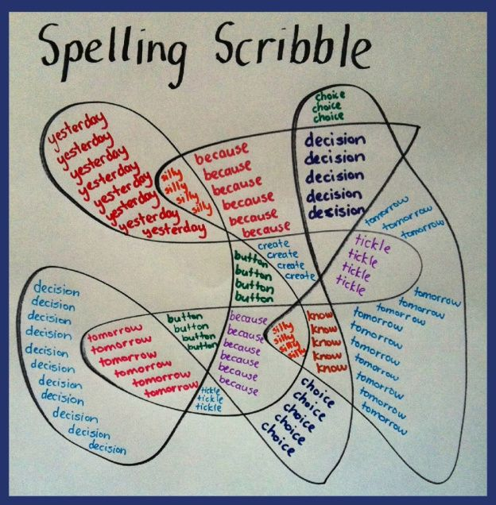
- Nessy reading spelling challenge
- This weeks spelling words – focus ending -ant/-ent: expectant, hesitant, decent, frequent, assistant. Practise using the free spelling tile games on Spelling Frame here.
- Make a ‘spelling scribble’ of your spelling words. See example.
- Write each spelling using pyramid writing: expectant, hesitant, decent, frequent, assistant
- Look, cover, write, check each spelling or ask a grown up to ‘quiz’ you on this weeks spellings.
Weekly Reading (pick one per day)
- Bug Club – read a book from your allocated books and complete the quiz questions within the book.
- Read the following text based on healthy lifestyles (page 1) . Have a go at completing the comprehension questions (page 2)
- ‘Pobble 365 – The Old Railroad’ – Read the story starter on slide 1 carefully then have a go at answering the questions on slide 3.
- Oak Academy Reading Comprehension – Lesson 1
- Oak Academy Reading Comprehension – Lesson 2
Weekly Writing (pick one per day)
- This week, we would like you to have a go at writing a non-chronological report titled ‘Healthy Lifestyles.’ Remember to think about the features you will need to use in your writing e.g. headings/subheadings, past tense, 3rd person, pictures/diagrams etc. You can also watch the following video to help you. Also, consider your Year 5 grammar techniques e.g. relative clause, subordinate clause, expanded noun phrases and fronted adverbials. For extra support with grammar techniques, follow the link below. https://www.bbc.co.uk/bitesize/topics/zwwp8mn
You can use the Oak Academy links below to support you in writing your report.
- ‘Pobble 365 – The Old Railroad’ – Complete the sentence challenge on slide 2.
Challenge: Can you write some more sentences about the image using sentences that contain brackets? Slide 4: Can you improve the ‘sick sentences?’ Then, have a go at writing your own descriptive sentences about the image.
- Oak Academy Lesson 3: Identifying the features of non-chronological reports.
- Oak Academy Lesson 4: SPaG Focus/Modal Verbs
Oak Academy Lesson 5: Writing a non-chronological report.
Weekly Mathematics (pick one per day)
- Oak Academy Maths Lessons Monday – Friday: Decimals
- MyMaths Activities that have been set by your teacher for this week.
- NRich primary games: Dicey Operations
- TTRockstars – Year 5 battle against Year 6 – who will win?

*If you have been using other online maths resources like BBC Bitesize or The Maths Factor as an alternative to the Oak National Academy lessons and would prefer to continue with these, in addition to completing MyMaths challenges, then please continue to do so.
Weekly Projects:
Food Safety week takes place between 4th – 10th June.
- Create a list of rules around Health and Safety including thinking about food allergies, sitting down while eating, what to do with leftovers and rubbish, cleanliness. Also think about why those rules have been established.
- Make a delicious piece of food from scratch, following correct safety measures.
- Create flashcards to reinforce key messages of food safety and hygiene.
- Check out the food hygiene learning clips on BBC bitesize here.
- Other learning opportunities:
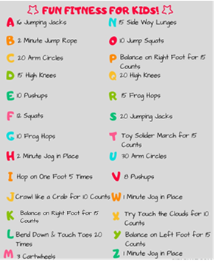
- D-Day happened on the 6th June. Carry out some research on D-Day.
- 30 days wild for June – have you completed any challenges so far? Can you do something wild everyday in June? Follow the link below to find out some more information. www.wildlifetrusts.org

- Fun Fitness! Spell out your name and complete the fitness activities. Do a fitness routine for each member of your house.

Remember, we would love to see your wonderful projects so please send a picture of them to our Year 5 email address. As more and more of you have been using the email address to communicate to your teacher please could you clearly indicate if you are happy for any pictures attached to be added to the school website gallery. Thanks.

