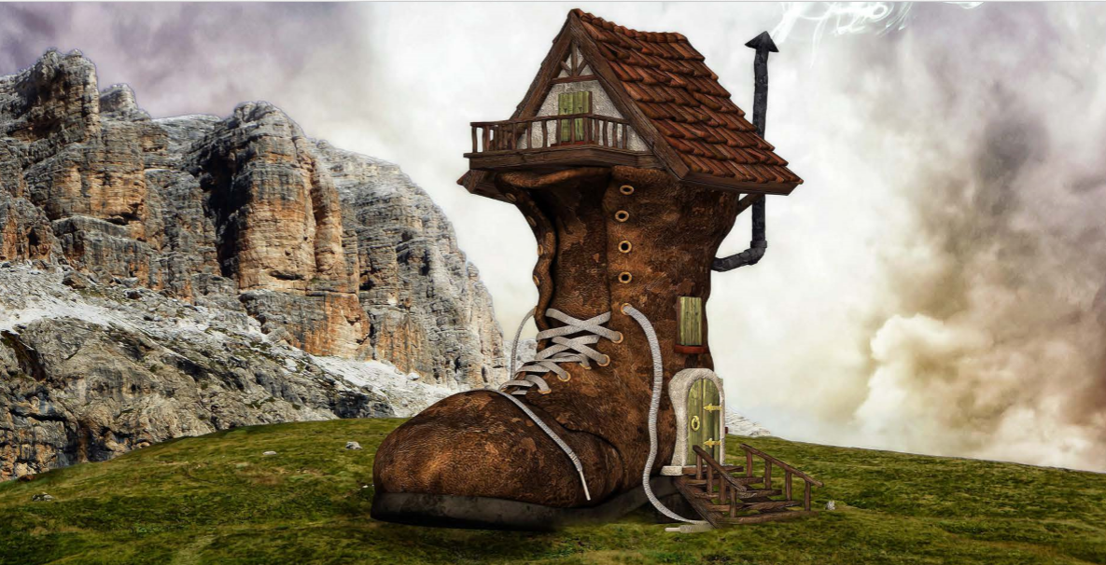

Can you write a description of this setting?
Think of the wonderful, rich language you could use.
This is a wonderful opportunity for you to use the expanded noun phrases that we have been practising.

