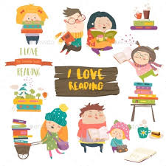For all Year 2 readers…

Why not extend your reading experiences by accessing the following resources:
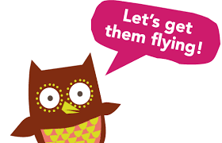
- Oxford Owl online resources for reading
The free e-library has lots of e-books for you to choose from.

Also go to ‘Kids Activites’ – ‘Cooking’
Try Make a Gingerbread Man
for readers aiming to be ‘secure’ or higher…
Try Making Pippi Pancakes
Try Melting Snowman Cookies
Try Isadora Moon’s Tingly Toes Hot Chocolate

If you want to read some more recipes and you like cooking, try out BBC GoodFood’s ’10 kids’ cooking projects’. How about making unicorn cupcakes or sunshine burgers!

- booktrust.org.uk has online resources for reading, mostly for children aiming to be ‘working towards’ or ‘secure’
In the BookTrust HomeTime – Hometime Hub section …
- Listen to a reading from Cressida Cowell (How To Train Your Dragon)
- Ed Vere’s ‘How to be a Lion’ is also great, and ‘Max The Brave’
Please remember, though texts can appear to be simple, the ideas can be the basis of brilliant discussions.
There are illustrations links too – the Gregosaurus looks great!

In the ‘storybooks and games’ section there are some interactive books to choose from.
Try ‘The Dragon Machine’ – it has some lovely ideas and vocabulary to discuss
‘Oh no George!’ and ‘Open Very Carefully’ are great books too.

- Pobble 365 online resources are good for developing ‘visual literacy’.
This is a resource bank of images with questions for discussion – great for developing inference and deduction skills. There are also literacy activity ideas as well.
If you click on the arrows at the sides of the images, you can access different images.
Please note, as the content of the images can vary (and includes KS2 images as well), an adult should check which images their child is going to access and discuss.

- Lots of stories for children who enjoy being read to.
Stories for children aiming to be ‘working towards’ or ‘secure’.

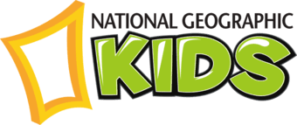
- National Geographic Kids – good for very confident readers
Visit the Discover section.
- Read about Mary Anning Facts in the History section.
- Read 10 Hopping Fun Rabbit Facts in the Animals section.
- Read 10 Fascinating Facts About Hibernation in the Science section.
- Read Fascinating Facts About The Sami People in the Geography section.
As with all internet use for Year 2 children – this website is best used with an adult as the website has a range of information for a range of ages.

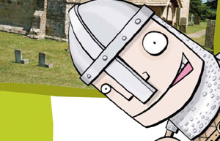
- BBC History for Kids – good for very confident readers
- Go to Ancient History and read about Ancient Greece and How did the Olympics begin?
- Go to World History and read about The Sutton Hoo Helmet

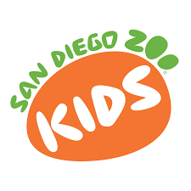
- San Diego Zoo Kids – good for very confident readers
- Go to Animals and read about Anna’s Hummingbird, the Burrowing Owl, the Echidna, the Fossa, the Gila Monster and the North American Porcupine.
There are some ‘Read Along And Learn’ stories about daily life at the zoo and some live animal ‘cams’.

- The Literacy Shed website has free reading comprehension packs – we have added links for these to Y2’s area of the school website. They also have downloadable ‘Key Stage 1 activity packs’ with visual literacy questions about the film clips, and nice ideas for links to written work.

- Find out more about the authors you like.
www.roalddahl.com
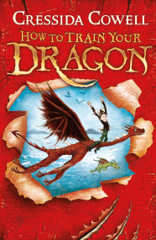 www.cressidacowell.co.uk
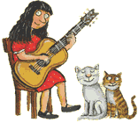www.juliadonaldson.co.uk

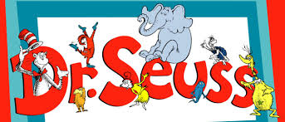 www.seussville.com

- Visit 3dgeography.co.uk - for very confident readers
Choose a country to find out about or a geography topic to read about.

- Ask your grownup to look at schoolreadinglist.co.uk – there are recommended texts for each age group.

- You may choose to subscribe to a children’s magazine. Here are some examples.
- National Geographic Kids
- Anorak
- Okido
- Storytime
- Aquila
- Story Box or Adventure Box
- Whizz Pop Bang
- The Week Junior
- Amazing!
- Brilliant Brainz

