March
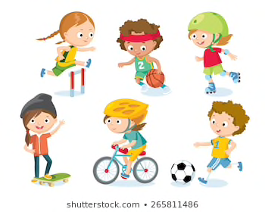Year 2: Ideas for projects 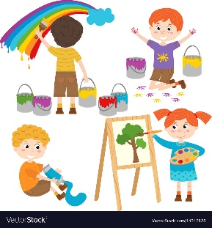

Sporty
- run your ‘Daily Mile’
- create a mini-assault course in your back garden, e.g. include a ‘hit the button’, a ladder stepping section, a throwing challenge, a jumping challenge.
- make up your own Terrific Tens, e.g. 10 star jumps, 10 touch your toes and stand up tall, 10 hopscotches, 10 marches on the spot
- teach your family how to do a ‘Bean’ warm-up
- teach your family how to play Snatch, I’m a Big Green Dragon, Keeper of the Keys
- try an online Cosmic Kids yoga challenge
- ask an adult to make a Number Hunt for you to run around and answer
- plan a training session to teach a child a skill for a sport you like, e.g. how to dribble a ball or do a trick in football, how to skateboard, how to ride a bike, how to do a backflip in gymnastics. Perhaps an adult could film you. You could explain the skill and demonstrate the skill. If you save it on a memory stick, our class could watch it together.
- perform a gymnastics or dance routine. Perhaps an adult could film you. If you save it on a memory stick, our class could watch it together.
Perhaps you could play a musical instrument or sing a song or read a poem instead.

Arty
- collect cereal boxes and tubs – make a junk model, e.g. a spaceship, a crazy vehicle, a monster, a house for a storybook character
- draw a portrait of each member of your family – create a family portrait gallery
- make Easter decorations for an Easter tree, e.g.
- draw, colour and cut out bunnies
- make egg, chick or bunny bunting
- paint hard boiled or blown eggs and hang them on your tree
- create a sock puppet or finger puppets – make up a story including your puppet, perhaps an adult could film you and you could show us in school
- make your own sculpture, e.g. use Lego, Jenga blocks, plasticine
- design a house for a storybook character
- try some easypeasyandfun.com or happinessishomemade.net projects
Take a photo of your project and bring it into school to share.

