Year 2 Topic, Science and Computing

Year 2 children may enjoy using some of these websites with support from an adult.

BBC Bitesize KS1 has child-friendly resources for all subjects of the curriculum.
Computing
https://www.bbc.co.uk/bitesize/subjects/zyhbwmn

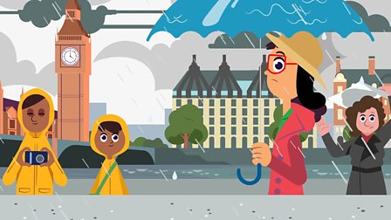 Geography
https://childhood101.com/online-geography-games/
Try some of the online Geography games for children.
‘World Geography Games’ has oceans and continents challenges.
https://www.bbc.co.uk/bitesize/topics/zyhp34j
Try exploring the world.
You could even try to learn a language, e.g. German, Mandarin, French or Spanish

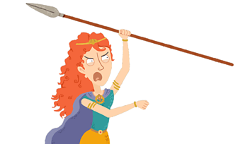History
www.bbc.co.uk/history/forkids
https://www.historyforkids.net/middle-ages.html
http://www.fireoflondon.org.uk/game/

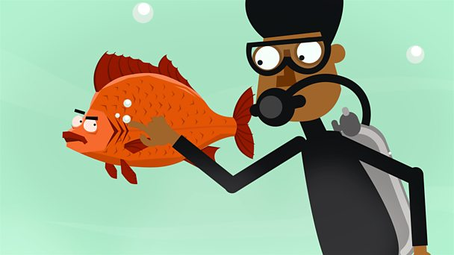Science
https://wowscience.co.uk/index
https://www.bbc.co.uk/bitesize/topics
Try KS1 Science Game – Dinosaur Discovery
Find out about animals, plants, the human body, habitats and the environment
https://www.tvokids.com/school-age/games/dino-dig-dino-dan

