**Year 4 Activity Suggestions**

Things to occupy children constructively during a break from school -

**Maths**

* Access MyMaths for assigned tasks.
* Access TTRockstars for Times tables practise.
* Number bonds (use playing cards).
* Any number based game such as Monopoly, Ludo or variations.
* Learn to play chess or draughts.
* Learn a card game to play in a group and one to play solo.
* Invent a card game.
* Do some cooking or baking that involves careful, accurate measuring.
* Improve your ability to tell time – if you are going to be staring at the clock, you might as well understand it.

Card games

Playing cards are cheap and provide excellent opportunities for ‘fun’ maths.

21s (Pontoon, Twist etc) (summary of rules attached)

This is a perfect example of a maths game. It has very simple rules (make sure you agree these beforehand as people play slight variations).

Bear in mind that the purpose is the maths. It helps to have all players *show* their cards rather than hide them as this allows help with calculation strategies. The game involves both addition and subtraction (and even a chance to discuss probability). This needs to be brought out by the adult. Encourage children to use strategies (see attached) to add and subtract rather than counting on fingers. Remember, we are aiming for instant recall of number facts, so repetition is vital.

Get the child to total their cards and then work out what they need to reach 21, or to beat an opponent. This allows mental subtraction to be practised. If a child ‘busts’ by going over 21, encourage them to ‘do the maths’ to find their actual total.

Discuss how you might make these calculations easier. Look for strategies that work for the child: there are often several ways to approach a problem and what works best for you may not be their best approach.

Varying the rules

Once a game is familiar to the child, it can be varied to allow more complex calculations. Instead of 21, play to 25 or 31. Ask what is the highest theoretical number of cards you could use to reach 21? This could be explored by choosing as many small cards from the pack as possible. This encourages children to think about maths as a problem to be solved and that they need to devise a strategy for.

Make up your own game

Children often enjoy inventing a game and making up the rules. Again, this makes them think about maths as an enjoyable and rewarding problem to be solved. Reward them by playing the game with them and talking about how they came up with the rules, what their advice is for strategies and how the game could be improved.

Teach them to use the cards for individual practise

It is usually best to take out the picture cards for this sort of practise. Show children that just turning over the cards ‘gets the cards to ask them questions’ about their target learning.

At first, the child needs a list of the target facts (say the 6 times tables) to check they are answering correctly. The aim is to put this aside and do the task purely from memory)

This is useful for:

* Number bonds to 10, 20, 30 etc. Turn over a card and as quickly as possible, give the number bond (eg turn over a 4, say 6).
* Times tables. Turn over a card and multiply this number by your target times table.
* Addition or subtraction. Start at zero and add each card you turn over. Star at 50 and subtract each card you turn over. Check your answers at first with a calculator, on you fingers or with a partner, but aim to be adding or subtracting confidently mentally.
* Addition or subtraction. Turn over three cards, make a two-digit number with the first two and add (or subtract) the third. This can be varied to make the task harder. This builds flexibility, especially where children have to carry out an addition followed by a subtraction.
* Working in multiples of ten. Turn over two or more cards. Make a two-digit (three-digit etc) number and multiply it by ten (or any other number)

Use cards to generate problems

Take out all the picture cards from a pack. Starting on 50, turn over cards one at a time. If the card is black, add it to your running total, if it is red, subtract it. This builds flexibility, as well as practising addition and subtraction over the tens boundary (eg 43 -7 requires you to go over the ‘tens boundary’ into the 30s, which is where confusion sometimes arises).

There are many ways to use cards to practise maths. The above is just a small introduction. There are many good examples on the internet or you may have favourites of your own. Be inventive and have fun!

Dice

Children love dice and all dice games have an element of maths. For a small cost you can buy more ‘interesting’ dice, for example 8 sided, 12 sided or even 20 sided dice. Children love these even more!

Again, there are hundreds of dice games, many of which you may know. A simple game is called ‘Pig’.

Pig

Two or more players take turns to roll one or more dice, keeping a running total as they do so. The aim is to reach 50. However, if a player rolls a 1 they lose all of their points and the next player takes their turn. If you are using a 20 sided dice you might change this to, say, any number below 5, so that the risk of losing your accumulated total is greater. To avoid this, the player can, at any point, ‘bank’ their score and pass the turn to the next player. Banked scores cannot be lost. In the next round, the player starts from their ‘banked’ score.

Variations on pig

Change target to 100.

Start on 50 and subtract each roll of the dice, aiming to reach zero.

Every roll is multiplied by ten and the target is 500

Once again, be imaginative and have fun!

**Card game rules**

**21**

Aim: make or get as close to 21 as possible without going over or ‘busting’.

* Dealer gives each player two cards.
* In turn, dealer asks players if they wish to ‘stick’ on their number or take another card to try to get closer.
* Once a player has decided to stick or has bust, the dealer moves on to the next player until all have had a turn.

The winner is the player with 21 or closest to it.

If two players have the same score (eg 19) the one who has used the highest number of cards wins.

A five (or more) card trick beats all hands

Possible variations

You may know slightly different rules, eg that a five card trick only beats a lower or equal number. Make sure you agree these beforehand. Having variations in rules encourages children to focus on the game.

Maxing the maths

The biggest difference in the version we play at school is that we ask the children to show their cards. Of course, this takes away the element of ‘bluff’ involved, but it makes the maths element much more transparent and allows lots of discussion about maths strategies.

Encourage children to use maths tricks to add their total or work out what they need to reach 21. Avoid counting on fingers. Some general maths strategies are described below. Building fluency with these strategies and with number facts is, of course, the whole purpose of the game.

To make the maths harder, change the target number to 25 or 31 etc. You will probably find children are keen to do this.

Even if a child obviously ‘busts’, encourage them to ‘do the maths’ and work out their total and how many they bust by.

Before taking an additional card, ask the child questions like:

What do you need to reach 21?

What is the highest card you can get without busting?

What do you need to beat the current leader?

**Snap**

We play a variation on snap in school. The dealer turns over the cards one by one and children add each card to the last one. If two subsequent cards are seen that add up to a target number, the first to shout snap, or the target number wins those cards.

The winner is the person with the most cards once the dealer has none left.

Possible variations

The biggest variation in this simple game is whether you allow children to grab the cards as they say snap. We discourage this as it leads to arguments!

Maxing the maths

Change the target number regularly. This builds fluency with different number facts and encourages flexible thinking. The target can be anything up to 20, but more ‘snaps’ will be found with target numbers between, say 8 and 15. A number bonds grid is attached to help children to see these useful number facts.

As the children watch the cards turned over, get them to find each total and say it out loud so you can check their accuracy.

Encourage mental maths strategies (see below). Discourage counting on fingers.

**Describe my number**

One person is ‘on’. They hold the deck on their lap and turn over a card, showing it to the others without looking at it. Each person in turn has to describe the card mathematically. The person who is ‘on’ has to work out what the card is.

A score can be kept of how many correct answers, but this is a game children seem to enjoy without having to have a winner.

Maxing the maths

This game allows children to work at their own level, but encourage them to challenge themselves and the person who is ‘on’. For example, to describe the number 5, a simple addition sentence is possible, but encourage the use of higher skills such as division or doubling and halving. More complex or challenging additions and subtractions are also possible. You could also relate it to times tables practise, for example “This number multiplied by 9 is 45”.

Model higher order skills when it is your turn and reward more challenging questions, perhaps by awarding double points.

**Maths strategies**

As mentioned above, the purpose of these games is to improve recall of number facts, but also of calculation strategies. Children tend to default to the strategy they know works, e.g. counting on their fingers. This is, of course, limited and slow so we need better mental strategies, which require explanation and practise.

Children will have been taught these strategies in school, and had some opportunity to practise, but your input will help them progress more rapidly. These skills pay dividends once a child starts to encounter more complex formal calculations.

Here are a couple of key strategies children can use to add mentally, which use the visual element provided by playing cards to make them clearer. If you have strategies of your own, please share them with your child. Everyone ‘sees’ numbers in different ways and your strategy may work for them.

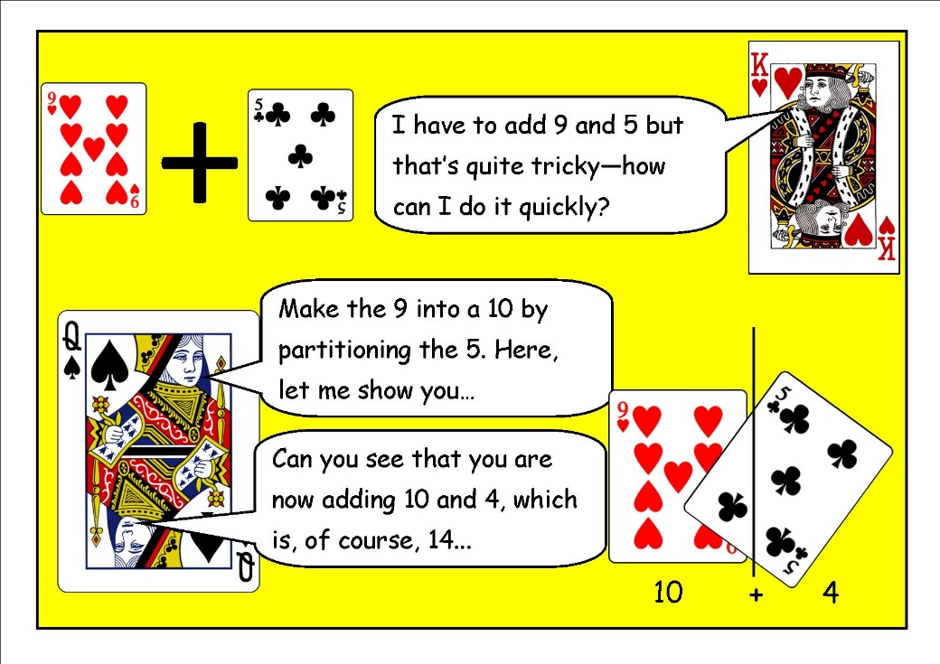

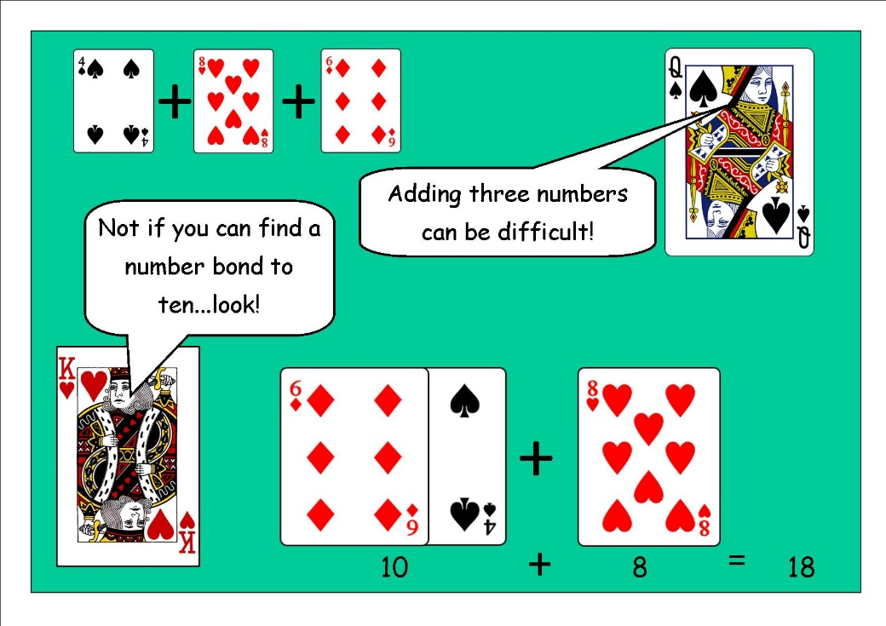

Telling the time

Support from home is invaluable when teaching children to tell the time.

Essentially, all children should be able to tell the time using an analogue clock to the nearest five minutes by the time they are in Year Four. However, children also need to be able to convert analogue time to digital in order to build up to using the 24 hour clock.

Please tell the time as much as possible and practise using timetables to calculate differences between times, e.g. if a programme starts at 4.30pm and finishes at 5.25pm, how long is the programme on for? If I sit down to watch TV at 4.55pm, what programme will be on? Remember, repetition is key to developing accuracy and confidence.

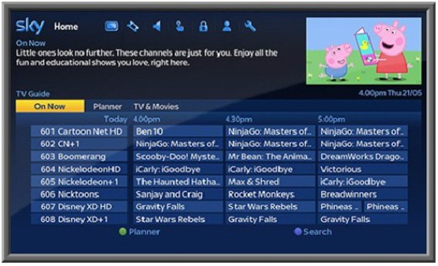

Measures

You can help by providing real-life opportunities for children to estimate and measure in a variety of situations.

* Baking
* Measuring liquids
* Using tape measures etc.
* Converting between different units of measure, e.g 0.5kg = 500g.

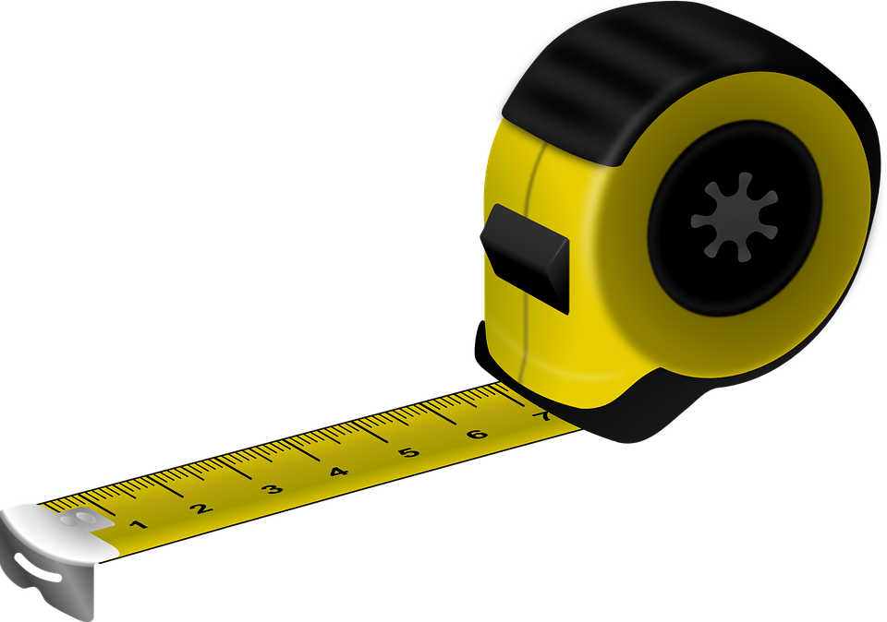

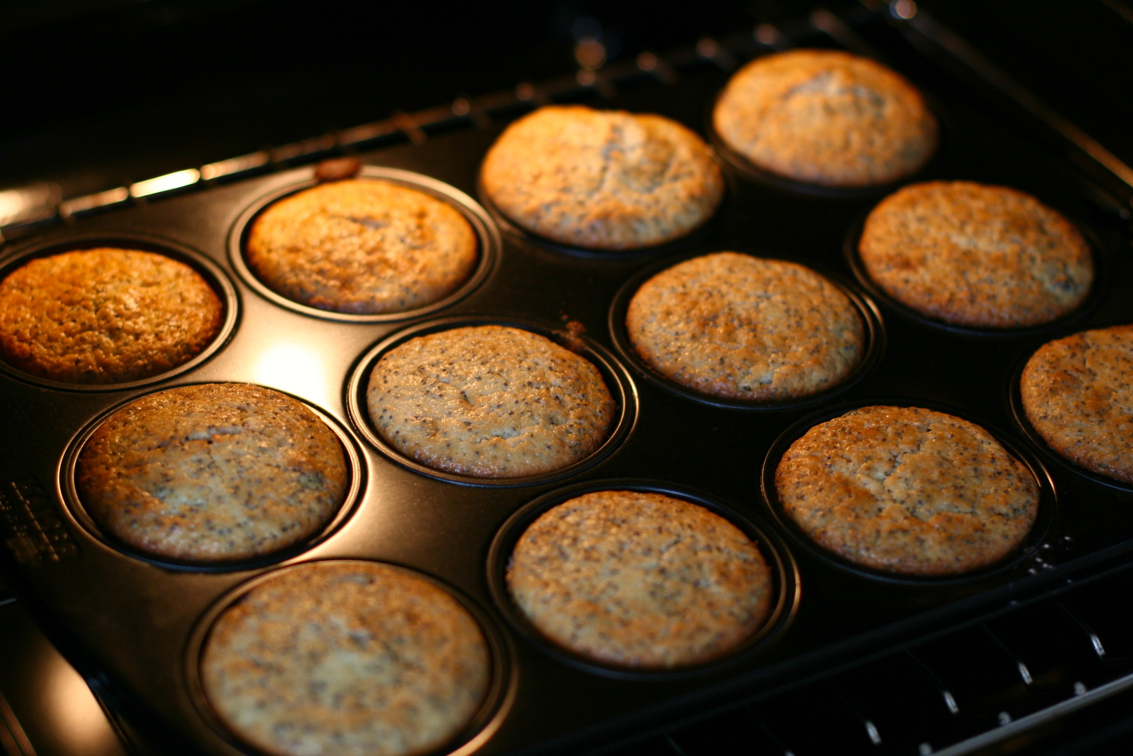

Money

Many children have little concept of money in today’s ‘plastic’ dominated world.

Simply allowing children to count a spare change pot develops coin awareness and little tricks, e.g. counting the largest values first, ‘grouping’ the ones into tens etc.

Where possible, allow children to pay for items, to approximate if they will have enough for several items, and calculate change.

Once secure, ask children to reason, will it be better value to buy the items in a multipack or as single items? If there is a special offer, how much will I save?

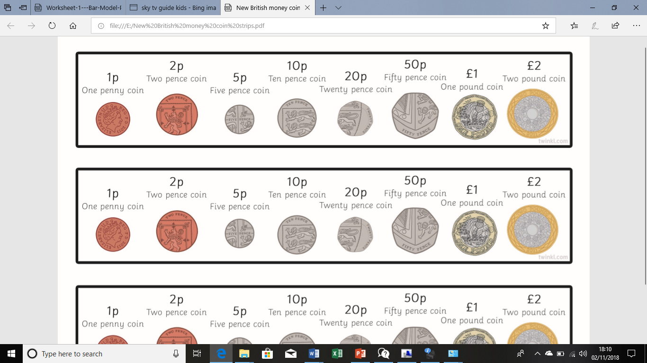

Fractions

* Recognise fractions in real life situations, e.g. when slicing a pizza into eight equal slices, discuss 2 eighths are equal to 1 quarter; 4 eighths are equal to 1 half etc.
* How many chunks of chocolate are there in half of the bar?
* Would you prefer to have two thirds of the bar or three fifths?
* Calculate fractions of amounts, e.g. half of 120.



* 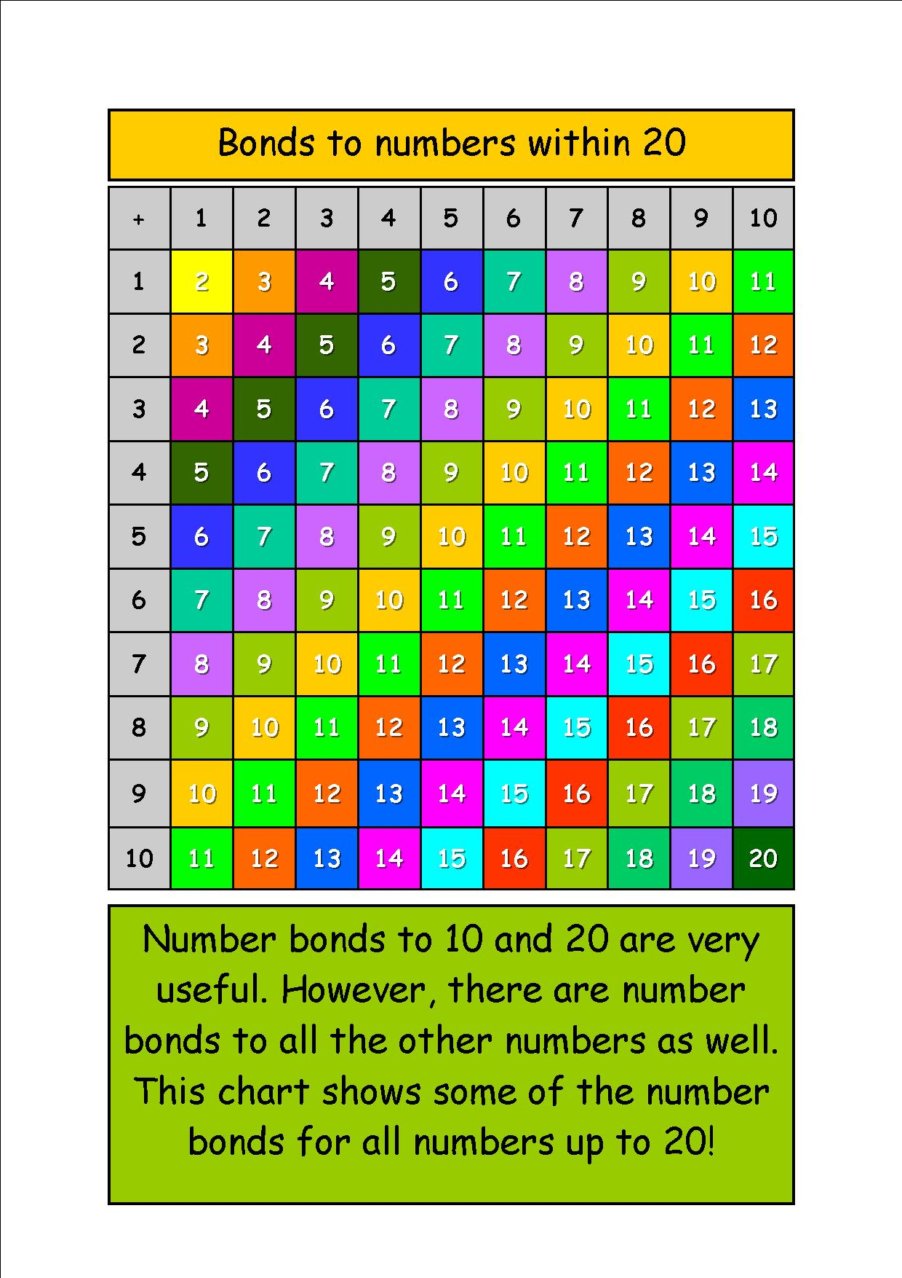

English

* Access bugclub and read books that have been assigned to you.
* Keep a diary of the events. This will be a major talking point for years to come.
* Read a book that has been on your shelf a while.
* How many different genres can you find at home? E.g. recipes, newspapers, instructions, comics, poem, story.
* Research a new hobby, such as origami
* Phone an elderly relative and ask them to tell you a story from their earlier life.
* Summarise their story in 30 words or less
* Read the first paragraph of a book. Now write the rest of the book yourself (or a summary of what you predict will happen). Read the rest of the book. Were you close?
* Make a set of characters using stones from the garden and paint. Invent names and characters for them. Do they have special abilities? Do they work as a team?
* Write letters and postcards to elderly relatives, neighbours or for residents of a local care home. Tell them about your hobbies and interest.
* Design the illustrations for a book you have read.
* Write an alternative ending for a story, e.g. Goldilocks gets sent to prison for stealing! Could you write it as a sensational newspaper article with headline and quotes.
* Investigate different myths and legends.

<http://myths.e2bn.org/mythsandlegends/>

* Create your own myth or legend <http://myths.e2bn.org/create/>

**Other ideas**

* Sort your bedroom and declutter – could some toys be given away?
* Make a dictionary puzzle game. Choose a tricky word. Write three definitions, one the correct one, two that you have invented. Challenge a member of your family to guess the correct definition
* Get out in the garden if possible. Each have a small patch of ground to clear, weed, dig, plant and cultivate. Whose patch will be the most colourful?
* Make a den in the garden, can you make it with three natural objects and three manmade objects?
* Take photos of signs of spring in your garden (e.g. new buds, daffodils, cherry blossom, birds building nests). Create a photo collage on your computer using your computing skills.
* Could you make a natural Scrap Book?
* Go on a bug hunt and research the bugs that you find on the internet.
* If you want a challenge, look carefully at the trees and plants in the garden and see if you can identify what species they are.
* Make a bird feeder, there are lots of ways to do this.
* Learn to use some tools with a capable member of the family. Could you design and make a small, wooden toy or something useful for the house like a towel rail?
* Build a den or fort from boxes, sheets, chairs and so on. Who will you invite? Who will you ban? Is there a password? How much of the room can you cover? Will you imagine the den is a spacecraft, a jungle hideout, a treehouse? Invent some stories about your den and write them down.
* Turn a cardboard box into a scene or house, perhaps for a younger child. How will you decorate it? Can you make furniture or vehicles for it?
* Learn to tie your laces.
* Learn to make your bed and change a single duvet cover.
* Decorate a hard boiled egg. Can you make an ‘eggciting’ character?

**Useful websites for educational games**

<https://www.mymaths.co.uk/>

<https://www.activelearnprimary.co.uk/login?c=0>

<https://ttrockstars.com/>

<https://nrich.maths.org/9413>

<https://uk.ixl.com/math/year-5>

<https://mathsframe.co.uk/en/resources/category/22/most-popular>

<https://www.topmarks.co.uk/>

<https://www.topmarks.co.uk/maths-games/hit-the-button>