**Year 5 Activity Suggestions**

**Things to occupy children constructively during a break from school -**

**Maths**

* Access MyMaths for assigned tasks.
* Access TTRockstars for Times tables practise.
* Number bonds (use playing cards).
* Any number based game such as Monopoly, Ludo or variations.
* Learn to play chess or draughts.
* Learn a card game to play in a group and one to play solo.
* Invent a card game.
* Create a marble maze from cuts of cardboard.
* Do some cooking or baking that involves careful, accurate measuring.
* Improve your ability to tell time – if you are going to be staring at the clock, you might as well understand it.

Telling the time

Support from home is invaluable when teaching children to tell the time.

Essentially, all children should be able to tell the time using an analogue clock to the nearest five minutes by the time they are in Year Four. However, children also need to be able to convert analogue time to digital in order to build up to using the 24 hour clock.

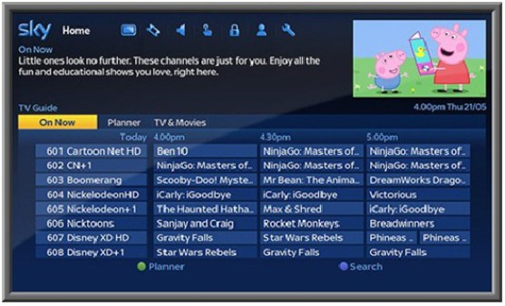

Please tell the time as much as possible and practise using timetables to calculate differences between times, e.g. if a programme starts at 4.30pm and finishes at 5.25pm, how long is the programme on for? If I sit down to watch TV at 4.55pm, what programme will be on? Remember, repetition is key to developing accuracy and confidence.

Measures

You can help by providing real-life opportunities for children to estimate and measure in a variety of situations.

* Baking
* Measuring liquids
* Using tape measures etc.
* Converting between different units of measure, e.g 0.5kg = 500g.

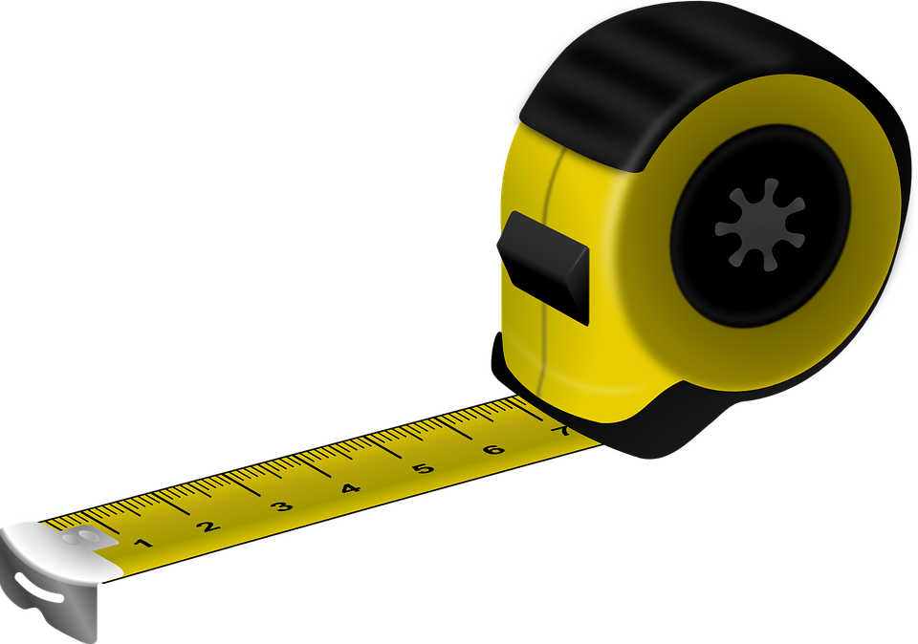

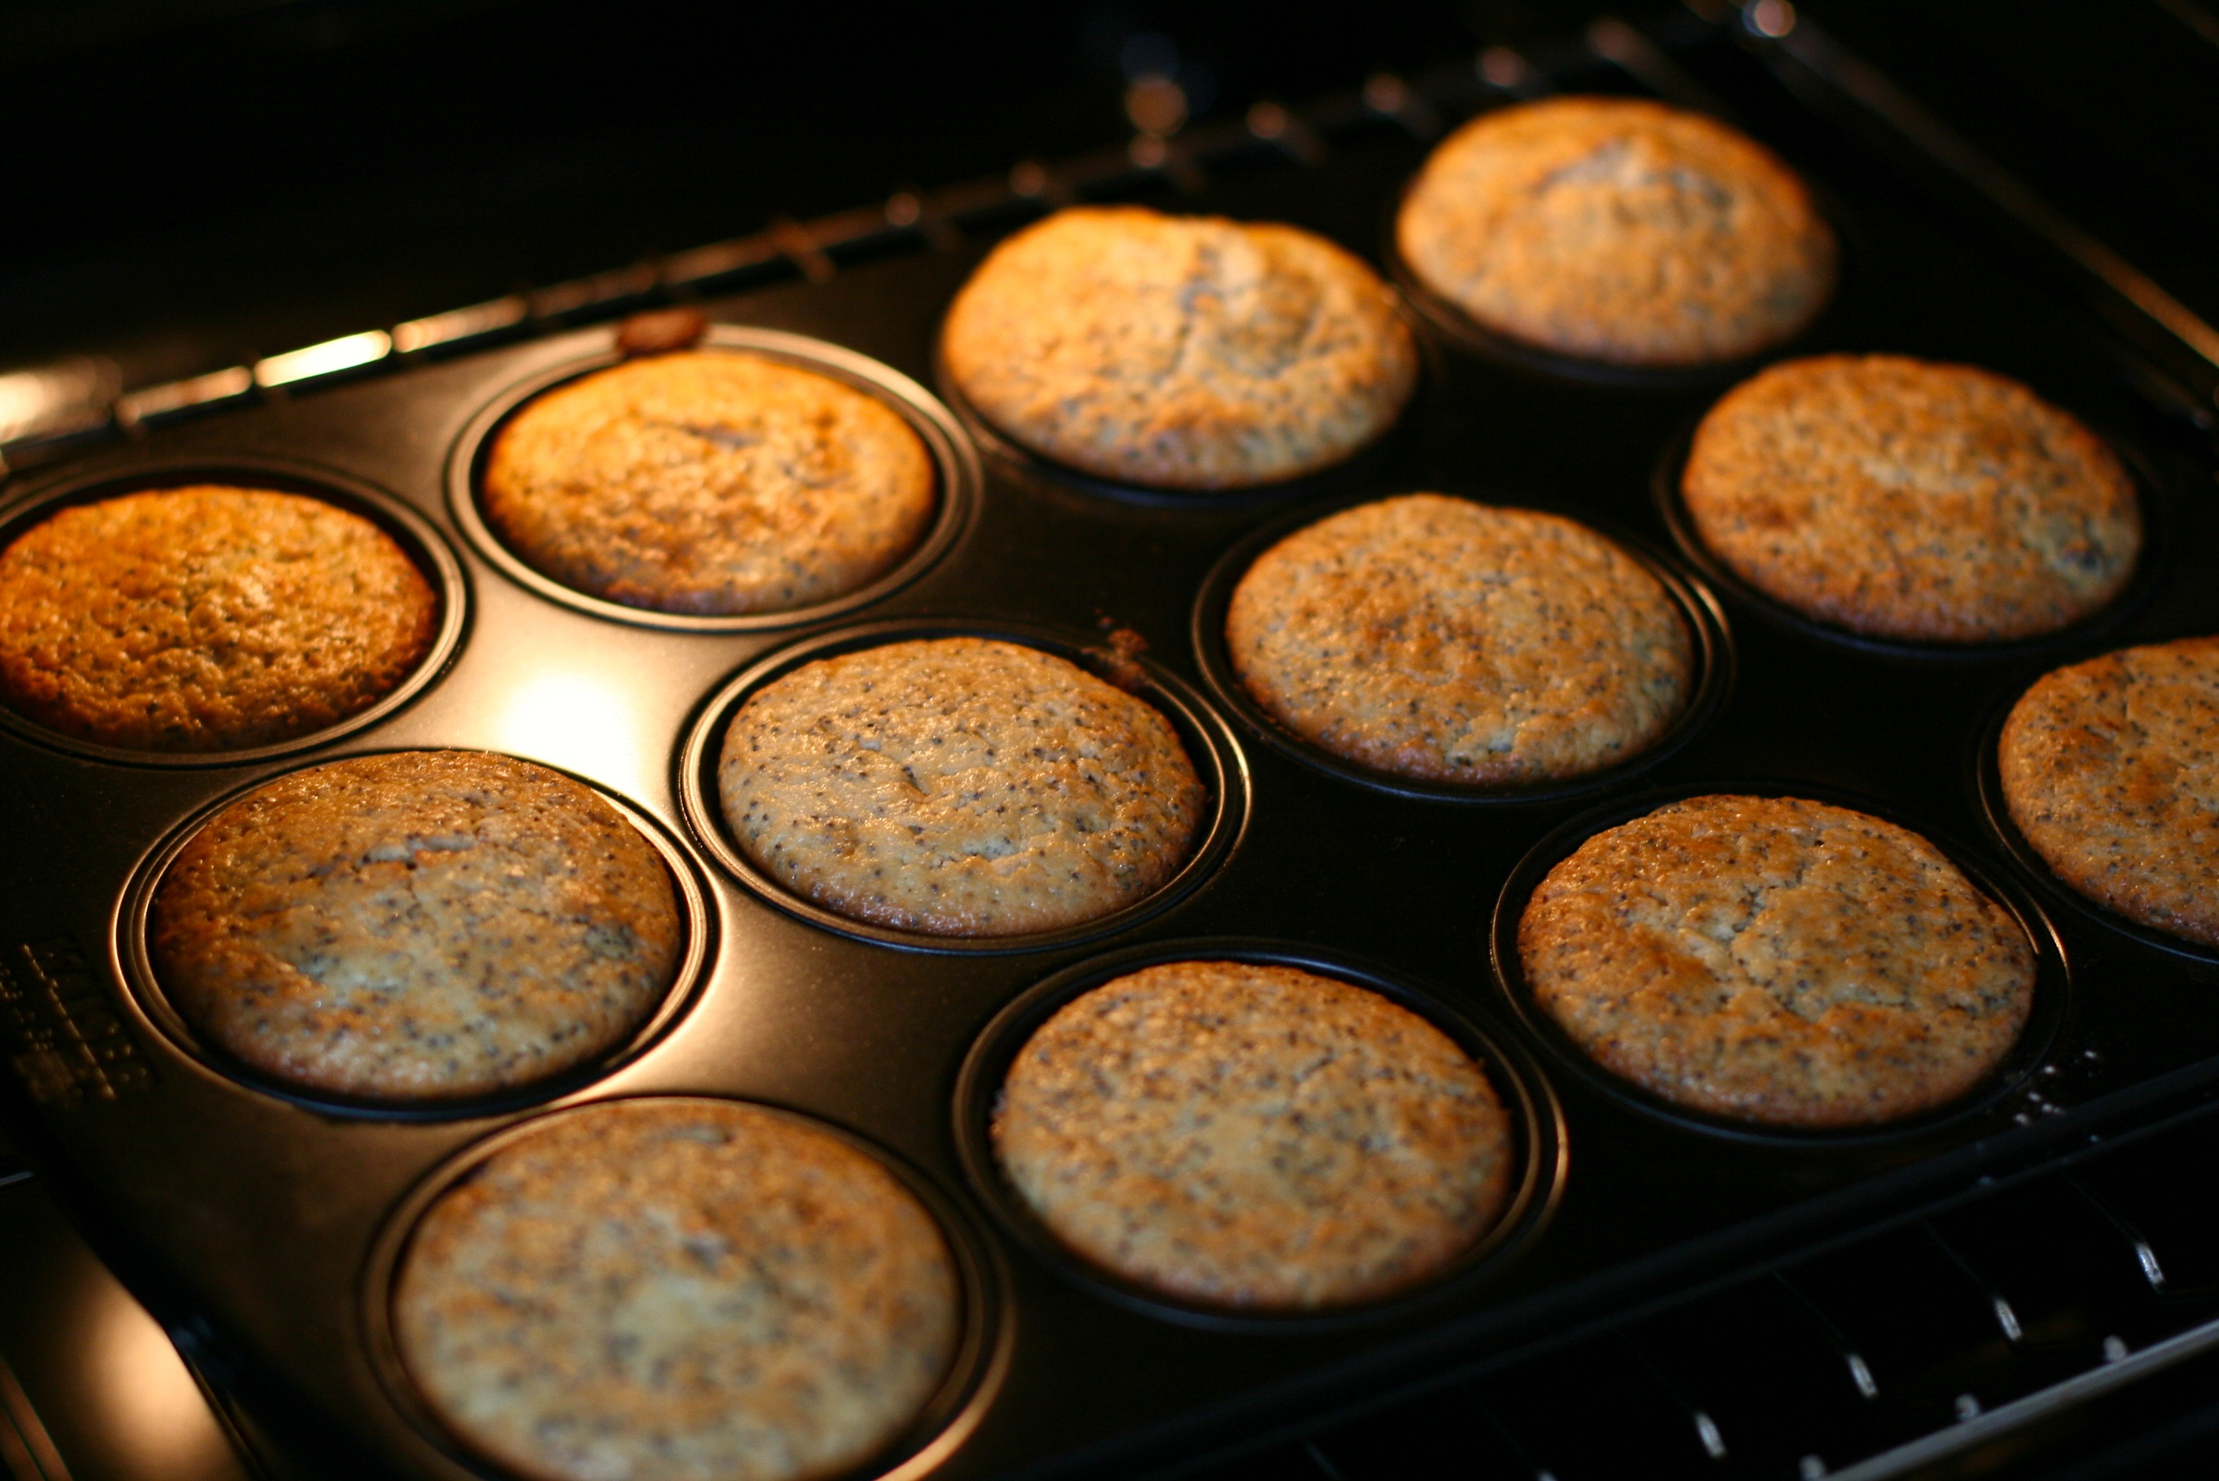

Money

Many children have little concept of money in today’s ‘plastic’ dominated world.

Simply allowing children to count a spare change pot develops coin awareness and little tricks, e.g. counting the largest values first, ‘grouping’ the ones into tens etc.

Where possible, allow children to pay for items, to approximate if they will have enough for several items, and calculate change.

Once secure, ask children to reason, will it be better value to buy the items in a multipack or as single items? If there is a special offer, how much will I save?

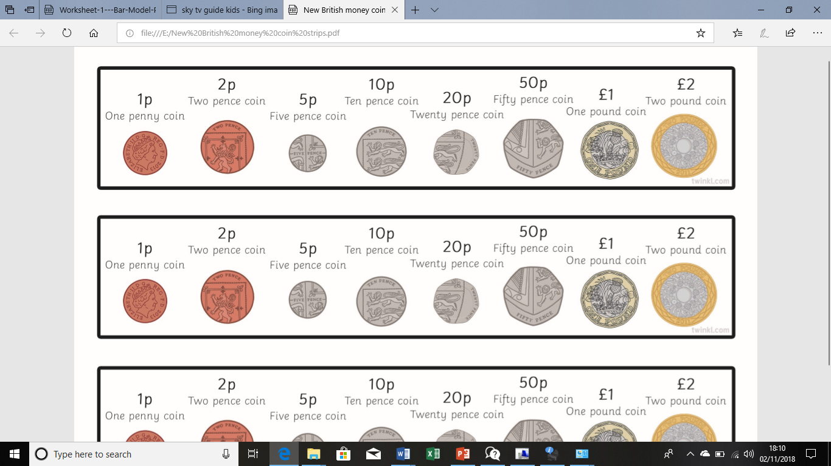

Fractions

* Recognise fractions in real life situations, e.g. when slicing a pizza into eight equal slices, discuss 2 eighths are equal to 1 quarter; 4 eighths are equal to 1 half etc.
* How many chunks of chocolate are there in half of the bar?
* Would you prefer to have two thirds of the bar or three fifths?



* Calculate fractions of amounts, e.g. half of 120.

**English**

* Access Bug Club and read books that have been assigned to you.
* Practise spelling the Year 5/6 statutory spellings – try using a variety of strategies to learn them such as creating fun mnemonics, rainbow writing, pyramid writing, silly sentences etc.
* Keep a diary of the events. This will be a major talking point for years to come.
* Read a book that has been on your shelf a while
* Research a new hobby, such as origami
* Phone an elderly relative and ask them to tell you a story from their earlier life.

Summarise their story in 30 words or less

* Read the first paragraph of a book. Now write the rest of the book yourself (or a summary of what you predict will happen). Read the rest of the book. Were you close?
* Make a set of characters using twigs, stones or other things. Invent their names and create stories for them. Do they have special abilities? Do they work as a team? Are they friends? What adventures do they go on?
* Write letters and postcards to elderly relatives, neighbours or for residents of a local care home. Tell them about your hobbies and interest.
* Write a fantasy story making sure you have a detailed character and setting description.
* Write instructions on how to do daily activities, how to wash up, how to mow the lawn, how to bake a cake etc…

**Topic**

* Research a North American country of your choice and create a fact file all about it. You could consider the currency, capital city, culture, traditional clothing, food, famous landmarks etc.
* Create a persuasive travel advert or brochure to persuade people to visit your chosen country.

**Science**

* Complete research on different types of forces. Could you make different sizes of parachutes to investigate air resistance.
* Create a fact file about a famous scientist such as Albert Einstein or Isaac Newton.

**PE**

* Complete a fitness workout. Try and find one by Joe Wicks.
* Teach a family member some dance moves.
* Go to BBC super movers and practise your favourite moves from any of the super movers videos.

**Other ideas**

* Sort your bedroom and declutter – could some toys be given away?
* Make a dictionary puzzle game. Choose a tricky word. Write three definitions, one the correct one, two that you have invented. Challenge a member of your family to guess the correct definition
* Get out in the garden if possible. Each have a small patch of ground to clear, weed, dig, plant and cultivate. Whose patch will be the most colourful?
* Learn to use some tools with a capable member of the family. Could you design and make a small, wooden toy or something useful for the house like a towel rail?
* Take photos of signs of spring in your garden (e.g. new buds, daffodils, cherry blossom, birds building nests). Create a photo collage on your computer using your computing skills.
* Could you make a natural Scrap Book?
* Go on a bug hunt and research the bugs that you find on the internet.
* If you want a challenge, look carefully at the trees and plants in the garden and see if you can identify what species they are.
* Make a bird feeder; there are many ways to do this.
* Build a den or fort from boxes, sheets, chairs and so on. Who will you invite? Who will you ban? Is there a password? How much of the room can you cover? Will you imagine the den is a spacecraft, a jungle hideout, a treehouse? Invent some stories about your den and write them down.
* Turn a cardboard box into a scene or house, perhaps for a younger child. How will you decorate it? Can you make furniture or vehicles for it?
* Research an artist and try to imitate their style. Romero Britto would be a fun artist to explore and imitate using felt tip pens! Have fun.

**Useful websites for educational games**

<https://www.mymaths.co.uk/>

<https://www.activelearnprimary.co.uk/login?c=0>

<https://ttrockstars.com/>

<https://nrich.maths.org/9413>

<https://uk.ixl.com/math/year-5>

<https://mathsframe.co.uk/en/resources/category/22/most-popular>

<https://www.topmarks.co.uk/>

Thank you for your continued support. Have some fun!

The Year 5 Team.